ERTMS/ETCS
System Requirements Specification
Chapter 5
Procedures
REF : | SUBSET-026-5
ISSUE : | 3.3.0
DATE : | 07/03/2012

Modification History
Issue Number  Date | Section Number | Modification / Description | Author / Editor
0.0.1 | Update of Class P document (version 1.1.1) on basis of Class 1 proposals |  | Kast, Hans
0.1.0  27.7.99 | Update according to decisions of review July 22/23 (Stockholm) |  | Kast, Hans
1.0.0  29.7.99 | Finalisation meeting in Stuttgart, 990729. |  | HE
1.2.0  990730 | Version number updated, Release version |  | HE
1.2.1  991209 | Updated according to proposals and comments from the ECSA/UNISIG database classified as “general” |  | Kast, Hans
1.3.0  991221 | Update according to decision of review meeting 15th/16th Dec. (Stockholm) |  | HK
2.0.0  991222 | Release version |  | HK
2.0.1  000919 | Debugging decisions (up to ...... ) included |  | HK
2.1.0  001017 | Update according to decisions of review on 10/11 Oct in Stuttgart |  | HK
2.2.0 | Version number | UNISIG release | SAB
2.2.2  020201 | Refer to document: SUBSET-026 Corrected Paragraphs, Issue 2.2.2 |  | HK
2.2.4 SG checked  28/05/04 | Including all CLRs agreed with the EEIG (see “List of CLRs agreed with EEIG for SRS v2.2.4” dated 28/05/04)  Affected clauses see change marks |  | H. Kast
2.2.5  21/01/05 | Incorporation of solution proposal for CLR 007 with EEIG users group comments  Corrections according to erratum list agreed in SG meeting 170105 |  | Hougardy A
2.2.6  31/01/05 | Including all current CR decisions (CR status “EEIG pending”) |  | H. Kast
2.2.7  22/07/05 | Including all current CR decisions by the UNISIG SG  22/07/05 CR 126 added |  | H. Kast
2.2.8  06/12/05 | Including all new CR decisions made since SRS version 2.2.7 (i.e., since July ’05) |  | H. Kast
2.2.9  24/02/06 | Including all CRs that are classified as “IN” as per SUBSET-108 version 1.0.0  Removal of all CRs that are not classified as “IN” as per SUBSET-108 version 1.0.0, with the exception of CRs 63,98,120,158,538 |  | H. Kast
2.3.0  24/02/06 | Release version |  | HK
2.3.1  15/06/06 | Including SG CR decision made since SRS 2.2.8, correct errors in 2.2.8 detected when creating SRS 2.3.0 |  | H. Kast
2.3.2  17/03/08 | Including all CRs that are classified as “IN” as per SUBSET-108 version 1.2.0 and all CRs that are in state “Analysis completed” according to ERA CCM |  | A. Hougardy
2.9.1  06/10/08 | Including all enhancement CR’s retained for 3.0.0 baseline and all other error CR’s that are in state “Analysis completed” according to ERA CCM  For editorial reasons, the following CR’s are also included: CR656, CR804, CR821 |  | A. Hougardy
3.0.0  23/12/08 | Release version |  | A. Hougardy
3.0.1  22/12/09 | Including the results of the editorial review of the SRS 3.0.0 and the other error CR’s that are in state “Analysis completed” according to ERA CCM |  | A. Hougardy
3.1.0  22/02/10 | Release version |  | A. Hougardy
3.1.1  08/11/10 | Including all CR’s that are in state “Analysis completed” according to ERA CCM, plus CR 731? 972 and 1000. |  | A. Hougardy
3.2.0  22/12/10 | Release version |  | A. Hougardy
3.2.1  13/12/11 | Including all CR’s that are in state “Analysis completed” according to ERA CCM |  | A. Hougardy
3.3.0  07/03/12 | Baseline 3 release version |  | A. Hougardy

Table of Contents
5.1 Modification History 2
5.2 Table of Contents 4
5.3 Introduction 7
5.3.1 Scope and Purpose 7
5.3.2 Definitions 7
5.4 Procedure Start of mission 9
5.4.1 Introduction 9
5.4.2 Status of data stored in the ERTMS/ETCS on-board equipment 9
5.4.3 Table of requirements for “Start of Mission” procedure 9
5.4.4 Flowchart 17
5.4.5 Degraded Situations 19
5.4.6 Entry to Mode Considered as a Mission 20
5.5 Procedure End of Mission 21
5.5.1 Introduction 21
5.5.2 Entry to Mode Considered as an End of Mission: 21
5.5.3 End of Mission Procedure 21
5.5.4 Degraded Situation 22
5.6 Shunting Initiated by Driver 23
5.6.1 Introduction 23
5.6.2 Table of requirements for “Shunting Initiated by Driver” procedure 23
5.6.3 Flowchart 24
5.6.4 Degraded Situation 25
5.7 Entry in Shunting with Order from Trackside 27
5.7.1 General Requirements 27
5.7.2 Shunting is requested for the current location (from modes different from Stand By and Post Trip) 27
5.7.3 Shunting is requested for a further location 27
5.7.4 Shunting from Stand By or Post Trip mode 28
5.7.5 Flowchart 29
5.8 Procedure Override 30
5.8.1 Introduction 30
5.8.2 Selection of “Override” 31
5.8.3 Once the “Override” procedure has been triggered 31
5.8.4 End of Override procedure 32
5.9 Procedure On-Sight 34
5.9.1 General Requirements 34
5.9.2 On Sight is requested for current location (from modes different from Stand By and Post Trip) 34
5.9.3 On Sight is requested for a further location 35
5.9.4 On Sight from Unfitted or SN mode 36
5.9.5 On Sight from Stand By or Post Trip mode 37
5.9.6 Exit of On Sight mode 37
5.9.7 Flowchart 38
5.10 Level Transitions 39
5.10.1 General requirements 39
5.10.2 Table of priority of trackside supported levels 40
5.10.3 Specific Additional Requirements 41
5.10.4 Acknowledgement of the level transition 47
5.11 Procedure Train Trip 48
5.11.1 Introduction 48
5.11.2 Table of requirements for “Train Trip” procedure 48
5.11.3 Flowchart 50
5.11.4 Degraded Situations 52
5.12 Change of Train Orientation 53
5.12.1 Introduction 53
5.12.2 The driver uses the same engine (a mission is on-going) 53
5.12.3 The driver leaves the engine to go to another one 53
5.12.4 The driver uses the same engine (a Shunting movement is on-going) 55
5.13 Train Reversing 56
5.14 Joining / Splitting 57
5.14.1 Definitions 57
5.14.2 Procedure “Splitting” 57
5.14.3 Procedure “Joining” 57
5.15 RBC/RBC Handover 59
5.15.1 Principles 59
5.15.2 Case 1: Two communication sessions can be handled simultaneously 59
5.15.3 Case 2: Only one communication session can be handled 62
5.15.4 Degraded Situations 64
5.16 Procedure passing a non protected Level Crossing 64
5.16.1 General Requirements 64
5.16.2 Stopping in rear of non protected LX is required 65
5.16.3 Stopping in rear of non protected LX is not required 65
5.17 Changing Train Data from sources different from the driver 66
5.17.1 Introduction 66
5.17.2 Table of requirements for “Changing Train Data from sources different from the driver” procedure 67
5.17.3 Flowchart 69
5.18 Indication of Track Conditions 71
5.18.1 Introduction 71
5.18.2 Passing a powerless section with pantograph to be lowered 71
5.18.3 Passing a powerless section with main power switch to be switched off 73
5.18.4 Passing a non stopping area 74
5.18.5 Passing a radio hole 75
5.18.6 Passing an “air tightness” area 76
5.18.7 Inhibition of a defined type of brake 77
5.18.8 Advising a tunnel stopping area 78
5.18.9 Sounding the horn 80
5.18.10 Changing the traction system 80
5.19 Procedure Limited Supervision 82
5.19.1 General Requirements 82
5.19.2 Limited Supervision is requested for current location (from modes different from Stand By and Post Trip) 82
5.19.3 Limited Supervision is requested for a further location 83
5.19.4 Limited Supervision from Unfitted or SN mode 84
5.19.5 Limited Supervision from Stand By or Post Trip mode 85
5.19.6 Exit of Limited Supervision mode 85
5.19.7 Flowchart 86

Introduction

Scope and Purpose

This document defines the procedures that are necessary for interoperability within the scope of ERTMS/ETCS.

Each procedure is defined by a set of mandatory requirements and, where convenient, is illustrated by a flowchart.

In case the condition(s) in chapter 4 triggering a mode transition is(are) fulfilled, this transition shall be executed even if not shown in the chapter 5 procedures.

Note: Such a mode transition could lead to exiting a procedure immediately (e. g. cut off power of on-board equipment, isolation of on-board equipment).

National operation rules (outside of ERTMS/ETCS) are also excluded, but may be applied by the railways in addition to the procedures as long as interoperability is retained.

Definitions

Procedures
A procedure defines the required reaction of the ERTMS/ETCS entities (subsystems and components) to either information exchanged between ERTMS/ETCS entities or events (triggered by external entities or internal events). The procedures focus on the required change in status and mode of the described ERTMS/ETCS entities.

Entities
The procedures define the required system behaviour on a context level, i. e. the entities that are used to define the procedures are for example: the on-board equipment, the trackside equipment (RBC/Balise), the driver.

States
States are situations of an ETCS subsystem with a specific set of available functions and a specific set of events that may start or terminate the state. A state remains active as long as the conditions to trigger the transition to a succeeding state are not completely satisfied.
Note 1: one mode of operation may include several states for the on-board equipment.
Note 2: A new state is only created, if the behaviour of the system differs from another one. Possession of information (e. g. location information) or not does not force branching in states.

Transitions
Transitions define the rules for passing from one state to another. A transition is triggered by a set of conditions which has to be fulfilled in a defined order or at the same time. When a transition refers to a driver’s selection, it means that the conditions to enable the corresponding button on the DMI were fulfilled.

Procedure Start of mission

Introduction

The driver may have to start a mission:
- Once the train is awake, OR
- Once shunting movements are finished, OR
- Once a mission is ended, OR
- Once a slave engine becomes a leading engine.

The common point of all these situations is that the ERTMS/ETCS on-board is in Stand-By mode, but the Start of Mission will be different, since some data may be already stored on-board, depending on the previous situation.

Once the ERTMS/ETCS on-board equipment is in Stand-By mode, the start of mission is not the only possibility, the engine may become remote controlled (i.e. the on-board switches to Sleeping mode).

Status of data stored in the ERTMS/ETCS on-board equipment

At the beginning of the Start of Mission procedure, the data required may be in one of three states:
- “valid” (the stored value is known to be correct)
- “Invalid” (the stored value may be wrong)
- “Unknown” (no stored value available)

This refers to the following data: Driver ID, ERTMS/ETCS level, RBC ID/phone number, Train Data, Train Running Number, Train Position (see 3.6.1.3).

Note 1: The status of data in relation to the previous and the actual mode is described in chapter 4, section "What happens to stored information when entering a mode".

Note 2: The change of status of data in course of the procedure is shown in the table in section 5.4.3.3.

Table of requirements for “Start of Mission” procedure

The ID numbers in the table are used for the representation of the procedure in form of a flow chart in section 5.4.4.

Procedure
ID # | Requirements
S0 | The Start of Mission procedure shall be engaged when the ERTMS/ETCS on-board equipment is in Stand-By mode with a desk open and no communication session is established or is being established.
S1 | Depending on the status of the Driver-ID, the ERTMS/ETCS on-board equipment shall request the driver to enter the Driver-ID (if the Driver-ID is unknown) or shall request the driver to revalidate or re-enter the Driver-ID (if the Driver-ID is invalid).  The ERTMS/ETCS on-board equipment shall offer the driver the possibility to enter/re-validate (depending on the status) the Train running number.  The ERTMS/ETCS on-board equipment shall also offer the driver the possibility to set/remove a Virtual Balise Cover.  Once the Driver-ID is entered or revalidated (E1) (possibly further to the Train running number entry/revalidation and/or to Virtual Balise Cover setting/removal), the process shall go to D2
D2 | If both the stored position and the stored level are valid, the process shall go to D3  If the stored position or the stored level is “invalid” or “unknown”, the process shall go to S2
D3 | If the stored level is 2 or 3, the process shall go to D7  If the stored level is 0,1 or NTC, the process shall go to S10
D7 | If at least one Mobile Terminal is registered to a Radio Network, the process shall go to A31  If no Mobile Terminal is registered to a Radio Network, the process shall go to A29
S2 | If the status of the Level data is "unknown", the ERTMS/ETCS on-board equipment shall request the driver to enter it.  If the status of the Level data is "invalid", the ERTMS/ETCS on-board equipment shall request the driver to re-validate or re-enter the ERTMS/ETCS level.  If the entered / re-validated level is 2 or 3, the process shall go to S3  If the entered / re-validated level is 0, 1 or one of proposed NTC level(s) (see 3.18.4.2 for the levels the driver is allowed to select), the process shall go to S10
S3 | The ERTMS/ETCS on-board equipment shall offer the possibility to the driver to re-enter the Radio Network ID. If the driver elects to do so, the on-board equipment shall acquire an alphanumeric list of available and allowed networks, based on a request to the Mobile Terminal(s) and:  - If this list is empty (E3) the process shall go to A29  - If the driver selects a new Radio Network ID from the proposed list, the registration of the Mobile Terminal(s) to this new Radio Network shall be ordered and the status of the RBC-ID/phone number shall be immediately set to “unknown”.  If at least one Mobile Terminal is registered to a Radio Network, the ERTMS/ETCS on-board equipment shall offer the following options to the driver for the RBC-ID/phone number:  - Only if the status of the RBC-ID/phone number is “invalid": order the ERTMS/ETCS on-board equipment to use the last stored RBC-ID/phone number  - Order the ERTMS/ETCS on-board equipment to use the EIRENE short number (trackside call routing function)  - Enter the RBC-ID/phone number (if its status is "unknown"), or revalidate/re-enter it (if its status is “invalid”).  Once the driver has selected the first or second option or once data is validated (E5), the process shall go to A31
A29 | The ERTMS/ETCS on-board equipment shall inform the driver that the Radio Network registration has failed  This condition leads to S10 (the driver has to unlock the situation to continue e.g. selection of new level)
S10 | The ERTMS/ETCS on-board equipment shall offer the possibility to the driver to select SH, NL, or to select Train Data Entry.  - If the driver selects SH (E12), the process shall continue in the same way as the procedure “Shunting initiated by the driver”.  If, in level 2 or 3, the RBC rejects the request for Shunting (E13), the process shall go back to S10.  - If the driver selects NL (E10) then the ERTMS/ETCS on-board equipment shall immediately switch to Non Leading mode (refer to SRS chapter 4, transition between modes: transition [46]). The mission starts in NL mode (if level is 2 or 3, the ERTMS/ETCS on-board equipment also reports the change of mode to the RBC).  - If the driver selects Train Data Entry (E11), the process shall go to S12  - Following E10, E12, if the position is still invalid, the ERTMS/ETCS on-board shall delete the train position data (new status: “unknown”)
S12 | The ERTMS/ETCS on-board equipment shall request the driver to enter/revalidate the Train Data that requires driver validation  .  Once Train Data is stored and validated (E16), the process shall go to D12
D12 | If Train running number is valid, the process shall go to D10  If Train running number is “unknown” or “invalid”, the process shall go to S13
S13 | If the status of the Train running number is "unknown" or “invalid”, the ERTMS/ETCS on-board equipment shall request the driver to enter/re-validate the Train running number now.  Once Train running number is entered/re-validated (E18), the process shall go to D10.
D10 | When the validated level is 2/3, the process shall go to D11  When the validated level is 0,1 or NTC, the process shall go to S20
D11 | When the session is open, the process shall go to S11, otherwise it shall go to S10
S11 | The ERTMS/ETCS on-board equipment shall send Train Data to the RBC.  When the RBC acknowledges Train Data (E14), then the ERTMS/ETCS onboard equipment shall go to the step S20.
S20 | The ERTMS/ETCS on-board equipment shall offer the possibility to the driver to select “Start”  - When the validated level is NTC and the driver selects "start" (E20), the process shall go to S22  - When the validated level is 0 and the driver selects "start" (E21), the process shall go to S23  - When the validated level is 1 and the driver selects "start" (E22), the process shall go to S24  - When the validated level is 2 or 3 and the driver selects "start" (E24), the process shall go to S21
S21 | The ERTMS/ETCS on-board equipment shall send an MA request to the RBC and wait.  If an SR authorisation is received from RBC (E26), the process shall go to S24  If an MA allowing OS/LS/SH is received from RBC (E27), the process shall go to S25  If an MA allowing FS is received from RBC (E29), the mission starts in Full Supervision mode (refer to SRS chapter 4, transitions between modes: transition from SB to FS)
S22 | The ERTMS/ETCS on-board equipment shall request an acknowledgement from the driver for running under supervision of the selected National System. When the driver acknowledges (E30) , the mission starts in SN mode (refer to SRS chapter 4, transitions between modes).  Following E30, if the position is still invalid, the ERTMS/ETCS on-board shall delete the train position data (new status: “unknown”)
S23 | The ERTMS/ETCS on-board equipment shall require an acknowledgement from the driver for running in Unfitted mode. When the driver acknowledges (E31), the mission starts in Unfitted mode (refer to SRS chapter 4, transitions between modes: transition from SB to UN)  Following E31, if the position is still invalid, the ERTMS/ETCS on-board shall delete the train position data (new status: “unknown”)”
S24 | The ERTMS/ETCS on-board equipment shall require an acknowledgement from the driver for running in Staff Responsible mode. When the driver acknowledges (E32), the mission starts in SR mode (refer to SRS chapter 4, transitions between modes: transition from SB to SR)  Following E32, if the position is still invalid, the ERTMS/ETCS on-board shall delete the train position data (new status: “unknown”)”
S25 | The ERTMS/ETCS on-board equipment shall require an acknowledgement from the driver for running in On Sight/Limited Supervision/Shunting mode. When the driver acknowledges (E33), the mission starts in On Sight/Limited Supervision/Shunting mode (refer to SRS chapter 4, transitions between modes: transition from SB to OS, LS or SH)
A31 | The ERTMS/ETCS on-board equipment shall open the session with the RBC.
D31 | If the opening of the session is successful, the process shall go to D32  If the opening of the session has failed, the process shall go to A32
A32 | The driver shall be informed when the on-board equipment fails to open a radio session.  Opening of a radio session has failed if  - No connection to the RBC can be established (see section 3.5.3.7) OR  - The ERTMS/ETCS on-board equipment, based on the system configuration reported by the RBC, decides that compatibility is not ensured and terminates the communication session  This condition leads to S10 (The driver has to unlock the situation to continue e.g. selection of new level).
D32 | If the stored position is valid, the process shall go to A33  If the stored position is invalid, the process shall go to A34
A33 | If the train position data stored in the on-board equipment is of status “valid”, the train position, marked as “valid” shall be transmitted to the RBC via the "SoM position report" message.  This condition leads to S10.
A34 | If the train position data stored in the on-board equipment is of status “invalid” or "unknown", the train position, marked as “invalid” or "unknown" shall be transmitted to the RBC via the "SoM position report" message.  The process shall then go to D33
D33 | When the position report marked as "invalid" is received by the RBC, this latter shall check whether it can validate this position report.  If the position report can be validated by the RBC, the process shall go to A35  Otherwise, if the position report was marked "unknown", or the "invalid" position report cannot be validated by the RBC, the process shall go to D22  Note: How the RBC is able to validate the position report is a national issue, out of the scope for this specification
A35 | The RBC shall inform the ERTMS/ETCS onboard equipment that the reported position is valid.  When this message is received by the ERTMS/ETCS on-board equipment, the status of the position shall be set to "valid"  The process shall go to S10.
D22 | If the reported train position is "unknown", or the RBC is not able to confirm a reported "invalid" position, the RBC shall nevertheless decide whether it accepts the train or not.  If yes, the process shall go to A23  If no, the process shall go to A38  Note: How the RBC assumes responsibility for the train is a national issue, out of the scope for this specification
A23 | The RBC shall inform the ERTMS/ETCS on-board equipment that it accepts the train although the on-board has no "valid" position information.
A24 | When the ERTMS/ETCS on-board equipment is informed that the train is accepted without valid position data, it shall delete the train position data (new status: “unknown”)  This condition leads to S10.
A38 | The RBC shall inform the ERTMS/ETCS on-board equipment that it rejects the train
A39 | When the ERTMS/ETCS on-board equipment is informed that the train is rejected, it shall delete the train position data (new status: “unknown”) and shall terminate the session with the RBC.  The process shall then go to A40
A40 | The ERTMS/ETCS on-board equipment shall inform the driver that the train is rejected  This condition leads to S10 (the driver has to unlock the situation to continue e.g. selection of new level).

The SoM procedure shall end as soon as at least one of the following conditions is fulfilled:
- Transition to any mode other than SB
- The desk is closed

Status of On-board Variables Affected by Start of Mission Procedure

 | State of On-board Variables
 | ERTMS/ETCS Level |  |  | RBC ID/Phone Number |  |  | Train position  data |  |  | Driver ID |  |  | Train Data |  |  | Train Running Number
Transition conditions | Un-known | Invalid | Valid | Un-known | Invalid | Valid | Un- known | Invalid | Valid | Un- known | Invalid | Valid | Un- known | Invalid | Valid | Un- known | Invalid | Valid
Following S1 : Driver has entered driver ID |  |  |  |  |  |  |  |  |  | ●
Following S1 : Driver has re-validated/ re-entered driver ID |  |  |  |  |  |  |  |  |  |  | ●
Following S1 : Driver has entered Train running number |  |  |  |  |  |  |  |  |  |  |  |  |  |  |  | •
Following S1: Driver has re-validated/ re-entered Train running number |  |  |  |  |  |  |  |  |  |  |  |  |  |  |  |  | •
Following D2: stored position is “invalid” or “unknown” |  |  | ● |  |  | ●
Following D2: stored level is “invalid” or “unknown” |  |  |  |  |  | ●
Following S2 : driver has entered level | ●
Following S2 : driver has re-validated/ re-entered level |  | ●
S3: driver has re-entered a Radio Network ID |  |  |  |  | ●
Following S3 : driver has entered RBC ID/Phone Number |  |  |  | ●
Following S3: driver has re-validated/re-entered RBC ID/Phone Number |  |  |  |  | ●
Following D31: session has been successfully opened |  |  |  |  | ●
Following D31: session has been successfully opened |  |  |  | ●
A35 : RBC reports to On-board : position valid |  |  |  |  |  |  |  | ●
A24 : On-board deletes stored position data |  |  |  |  |  |  |  | ●
A39 : On-board terminates session, deletes stored position data |  |  |  |  |  |  |  | ●
Following E10, E12, E30, E31, E32, On-board deletes stored position data |  |  |  |  |  |  |  | ●
Following 5.4.5.3 a), f), g), On-board deletes stored position data |  |  |  |  |  |  |  | ●
Following S12: Train Data have been entered |  |  |  |  |  |  |  |  |  |  |  |  | ●
Following S12: Driver has (re-) validatedTrain Data |  |  |  |  |  |  |  |  |  |  |  |  |  | ●
Following S13: Driver has entered train running number |  |  |  |  |  |  |  |  |  |  |  |  |  |  |  | ●
Following S13: Driver has re-validated/re-entered train running number |  |  |  |  |  |  |  |  |  |  |  |  |  |  |  |  | ●
Following S10 or S20: Driver chooses to re-enter the level |  |  | ● |  |  | ●

Flowchart

The ID numbers in the flowchart refer to the ID numbers of the table in section 5.4.3.

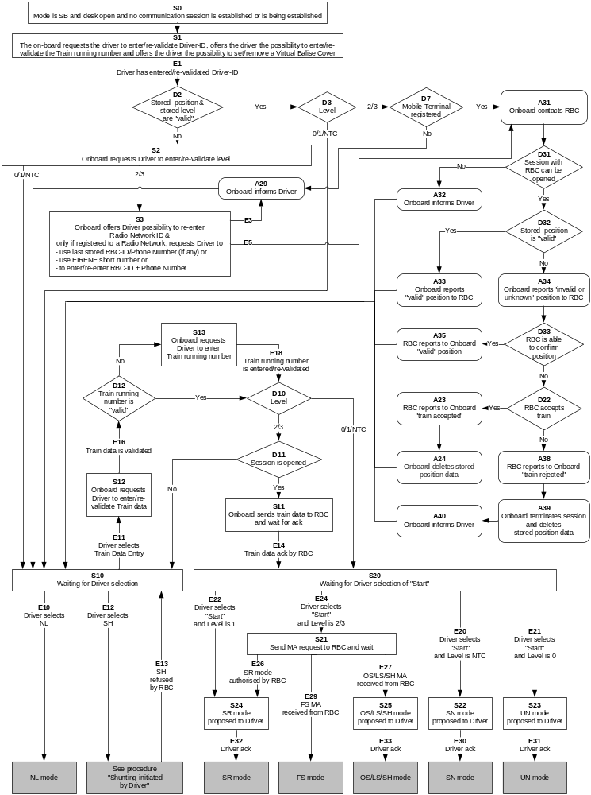
Figure 1: Flowchart for “Start of Mission”

Degraded Situations

Nominally, accidental loss of an already open session (that can occur at any step) has not been taken into account for the design of the SoM flowchart. However, should such a fault occur above D11 the nominal procedure applies (refer to D11 in flowchart). On the other hand, if it occurs in any step further than D11, the process shall go to S10.

The SoM flowchart described in section 5.4.3 only includes the main paths and does not exhaustively cover the various operational situations, which could occur while performing the SoM procedure (e.g. when revised instructions are given to the driver or when the driver needs to re-enter already captured data).

The ERTMS/ETCS on-board equipment shall also offer the driver the following possibilities, in addition to the ones that are described in section 5.4.3:
- only at S10 and S20 and if valid Train data is available, to select “Override”. If the driver chooses to do so, then the process shall go to the procedure “Override” and, if the position is still invalid, the ERTMS/ETCS on-board shall delete the train position data (new status: “unknown”)
- only at S10 and S20, to re-enter the Driver-ID
- only at S10 and S20,to re-enter the “Train running number”
- only at S20, to re-enter the Train data. If the driver chooses to do so, then the process shall go to S12.
- only at S10 and S20, to re-enter the Level. If the driver chooses to do so, then the process shall go to S2
- only at S20, to select “Non Leading”. If the driver chooses to do so, then the ERTMS/ETCS on-board equipment shall immediately switch to Non Leading mode and, if the position is still invalid, the ERTMS/ETCS on-board shall delete the train position data (new status: “unknown”).
- only at S20, to select “Shunting”. If the driver chooses to do so, then the process shall go to the procedure “Shunting initiated by driver” and, if the position is still invalid, the ERTMS/ETCS on-board shall delete the train position data (new status: “unknown”). If, in level 2 or 3, the RBC rejects the request for Shunting, the process shall go back to S20.
- only at S10, if valid Train Data is available, to select “Start”. If the driver chooses to do so:
- if the level is 0, then the process shall go to S23.
- if the level is NTC, then the process shall go to S22.
- if the level is 1, then the process shall go to S24.
- if the level is 2/3 and a session is open, then the process shall go to S21.
- if the level is 2/3 and no session is open, then the process shall go to S24.
- only at S10 and S20, to set/remove a Virtual Balise Cover.

Entry to Mode Considered as a Mission

A mission shall be considered as started as soon as the ERTMS/ETCS on-board equipment enters FS, LS, SR, OS, NL, UN, or SN mode.

Entry in all other modes, from SB mode, shall not be considered as a mission.

Procedure End of Mission

Introduction

End of mission refers to the situation where the trackside stops to authorise the movement of a unit. End of mission is initiated by the ERTMS/ETCS on-board equipment when entering specific modes (see below).

Entry to Mode Considered as an End of Mission:

Stand-By mode

From FS, LS, OS, UN, NL, SR, PT, RV or SN mode, the entry of the ERTMS/ETCS on-board equipment into the Stand-by mode is considered as an End of Mission

Note: While in SN mode (level NTC), some other conditions to end the mission may depend on the National System.

The entry of the ERTMS/ETCS on-board equipment into the Stand-by mode, from PT mode, is only considered as an End of Mission if there was an on-going mission.

Sleeping mode

The entry of the ERTMS/ETCS on-board equipment into the Sleeping mode is considered as an End of Mission.

Note: The transition to Sleeping mode is always made from the Stand-By mode (refer to chapter 4, transition between modes). If the end of mission has been already executed in Stand-by mode no further end of mission is required.

Shunting mode

The entry of the ERTMS/ETCS on-board equipment into the Shunting mode, from FS, LS, OS, SR, SN or UN mode, is considered as an End of Mission.

The entry of the ERTMS/ETCS on-board equipment into the Shunting mode, from PT mode, is only considered as an End of Mission if there was an on-going mission.

Note: While in SN mode (level NTC), some other conditions to end the mission may depend on the National System.

End of Mission Procedure

The procedure comprises the following steps

Step 1 - MA, Track Description Data and Train Data may be deleted (mode dependent, see Chapter 4, section "What happens to accepted and stored information when Entering a Mode").
End of Procedure, if there is no existing communication session.”

If a communication session with an RIU exists:
Step 2 - The ERTMS/ETCS on-board equipment shall terminate the communication session
End of procedure

If a communication session with an RBC exists:
Step 2 - The end of mission shall be reported to the RBC by means of the message “End of Mission”.
Step 3 - The RBC shall request to terminate the communication session.
Step 4 - The ERTMS/ETCS on-board equipment shall terminate the communication session
End of procedure

Note: For the termination of the communication session refer to chapter 3, Management of Radio Communication.

Note: The “End of Mission” message contains a position report.

Intentionally deleted.

Degraded Situation

Level 2,3 : In case a communication session is established and no request to terminate the communication session is received from the RBC within a fixed waiting time (see appendix to chapter 3, List of Fixed Value Data) after sending the “End of Mission” message, the message shall be repeated with the fixed waiting time after each repetition.

After a defined number of repetitions (see appendix to chapter 3, List of Fixed Value Data), and if no reply is received within the fixed waiting time from the time of the last sending of “End of Mission”, the ERTMS/ETCS onboard equipment shall terminate the communication session.

Level 2,3 : In case no communication session is open, no communication session shall be established to report the end of mission.

Shunting Initiated by Driver

Introduction

The procedure describes the selection of shunting by the driver.

Intentionally deleted.

Table of requirements for “Shunting Initiated by Driver” procedure

The ID numbers in the table are used for the representation of the procedure in form of a flowchart in section 5.6.3.

Procedure
ID # | Requirements
E015 | The train is at standstill and the ERTMS/ETCS on-board equipment is in FS, LS, OS, SR, SN, UN or PT mode or is in SB mode with necessary preconditions fulfilled (Driver ID known, Level known, ... see procedure "Start of mission").  When the driver selects Shunting (E015) the process shall go to D020.
D020 | If the current ETCS Level of operation is 0 or 1, the process shall go to A050.  If the current ETCS Level of operation is 2 or 3, the process shall go to A045.  If the current ETCS Level of operation is NTC, the process shall go to D030
D030 | If there is an on-going National Trip procedure reported by the STM, the process shall go to A030  Otherwise the process shall go to A050
A030 | The process shall go to the “Train trip" procedure
A045 | The ERTMS/ETCS on-board equipment shall send the “Request for Shunting” message to the RBC together with a position report (with special value “position unknown” if the position is not known)  The process shall go to S050.
S050 | The ERTMS/ETCS on-board equipment awaits the reply to the SH request.  If SH authorised is received from the RBC (optionally with a list of balise groups for SH area, which the train can pass when the ERTMS/ETCS onboard equipment is in shunting mode) (E090), the process shall go to A050.  If “SH refused” is received from the RBC (E215), the process shall go to A220.
A050 | The mode shall change to SH. Any previous list of balise groups for SH area shall be deleted or replaced by a new list of balise groups for SH area.  The process shall go to D040.
D040 | If there is an on-going mission, the process shall go to A100.  If there is no on-going mission, the process shall go to D080.
A100 | The process shall go to the “End of Mission" procedure
D080 | If the current ETCS Level of operation is 2 or 3, the process shall go to A095.  If the current ETCS Level of operation is 0, 1 or NTC the process shall END.
A095 | The mode change shall be reported to the RBC.  The process shall go to S100.
S100 | The ERTMS/ETCS on-board equipment awaits the RBC order to terminate the communication session.  When an order to terminate the communication session is received from RBC the process shall go to A115.
A115 | The ERTMS/ETCS on-board equipment shall terminate the communication session.  The process shall END.
A220 | An indication shall be given to the driver that SH was refused by the RBC.  The process shall END.

Flowchart

The ID numbers in the flowchart refer to the ID numbers of the table in section 5.6.2.
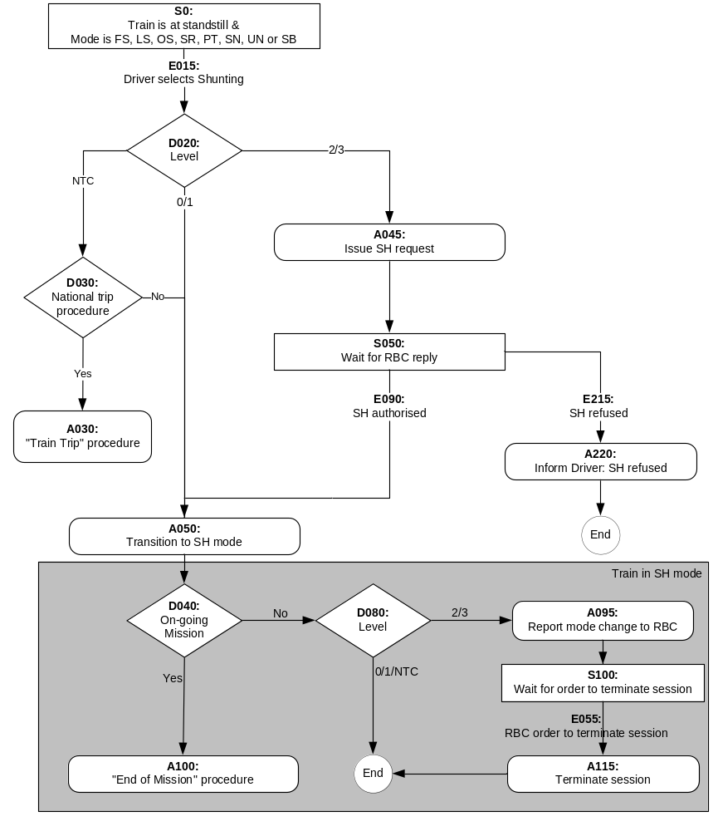
Figure 2: Flowchart for “Shunting Initiated by Driver”

Degraded Situation

ERTMS/ETCS level 2 or 3: no answer to Shunting request is received from the RBC

In case a communication session is established and no reply is received from the RBC within a fixed waiting time (see appendix to chapter 3, List of Fixed Value Data) after sending the “Request for Shunting” message, the message shall be repeated with the fixed waiting time after each repetition.

After a defined number of repetitions (see appendix to chapter 3, List of Fixed Value Data), and if no reply is received within the fixed waiting time from the time of the last sending of “Request for Shunting”,. the ERTMS/ETCS onboard equipment shall inform the driver and shall terminate the communication session.

If no authorisation for SH mode can be received from the RBC, refer to procedure “Override”.

ERTMS/ETCS level 2 or 3: in case a communication session is established and no order to terminate the session is received from the RBC within a fixed waiting time (see appendix to chapter 3, List of Fixed Value Data) after reporting the mode change, the report shall be repeated with the fixed waiting time after each repetition

After a defined number of repetitions (see appendix to chapter 3, List of Fixed Value Data), and if no reply is received within the fixed waiting time from the last sending of the mode change report, the ERTMS/ETCS onboard equipment shall terminate the communication session.

Entry in Shunting with Order from Trackside

General Requirements

This procedure is used to allow the entry of a train into a shunting area.

Note: The shunting area, possibly including a “safety envelope”, can be already occupied by shunting units, not controlled by the trackside. It is therefore possible that the train shall enter into the shunting area in OS mode. The switch to OS is performed according to the relevant procedure.

The order to switch to SH mode shall be given by means of a mode profile, optionally with a list of balises groups, which the train can pass when the ERTMS/ETCS on-board equipment is in shunting mode.

The switch to shunting, if the transition to shunting was ordered by trackside, requires a driver acknowledgement, according to the specifications below.

When the ERTMS/ETCS on-board equipment has switched to Shunting mode, End of Mission, according to chapter 5.5.2.3, is performed.

Shunting is requested for the current location (from modes different from Stand By and Post Trip)

In a level 1 area, or at the border from a level 0 to a level 1 area, the beginning of the shunting area can be the location where a balise group is installed. In level 2/3 it is possible to send an ERTMS/ETCS on-board equipment the order to switch to shunting at the current location.

Shunting is requested for the current location means that, according to the mode profile received the max safe front end of the train is at or in advance of the location for which switching to SH mode is requested.

The ERTMS/ETCS on-board equipment shall switch immediately to SH mode and a request for acknowledgement shall be displayed to the driver (refer to SRS chapter 4, transitions between modes).

If the driver does not acknowledge within the driver acknowledgement time (refer to Appendix A3.1) after the change to SH mode, the service brake command shall be triggered. The command shall be released as soon as the driver acknowledges (unless the command was triggered also for other reasons).

Shunting is requested for a further location

An order to switch to SH at a further location can be sent
- in a level 1 area by a balise group,
- in a level 2 or 3 area by the RBC.

A request for acknowledgement shall be displayed to the driver, when the following two conditions are fulfilled:
- the distance between the estimated front end of the train and the beginning of shunting area is shorter than a value, contained in the mode profile
- the speed is lower than the Shunting mode speed limit (National Value, or value given in the mode profile)

Once the request for acknowledgement is displayed, it shall not be taken back, even if the above conditions are no more fulfilled (e.g., the train accelerates).

Until the ERTMS/ETCS on-board equipment has switched to SH mode, according to the mode profile, the beginning of the shunting area shall be considered either as the EOA (keeping the SvL given by the MA) or as both the EOA and SvL (instead of the EOA and SvL given by the MA), with no release speed.

When the driver acknowledges, the ERTMS/ETCS on-board equipment shall immediately switch to SH mode (refer to chapter 4, transitions between modes).

If the max safe front end of the train reaches the beginning of the shunting area according the mode profile and the driver has not yet acknowledged, the ERTMS/ETCS on-board equipment shall switch immediately to SH mode and a request for acknowledgement shall be displayed to the driver (refer to SRS chapter 4, transitions between modes).

If, in this case, the driver does not acknowledge within the driver acknowledgement time (refer to Appendix A3.1) after the change to SH mode, the service brake command shall be triggered. The command shall be released as soon as the driver acknowledges (unless the command was triggered also for other reasons).

Shunting from Stand By or Post Trip mode

When performing a SoM or a Train Trip procedure and when the current level is 2 or 3, the ERTMS/ETCS on-board equipment can receive a mode profile giving an Shunting area which the train has already entered with its max safe front end. In this case, the ERTMS/ETCS on-board equipment shall first require an acknowledgement from the driver.

When the driver acknowledges, the ERTMS/ETCS on-board equipment shall perform transition to Shunting mode.

Flowchart
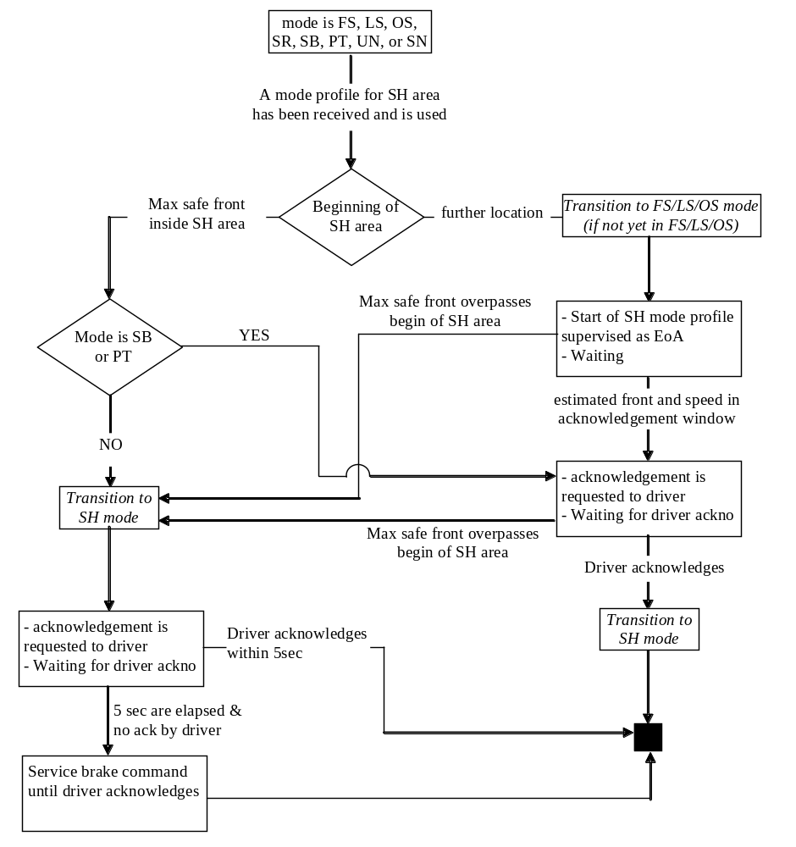
Figure 3: Flowchart for “Entry in Shunting with Order from Trackside”

Procedure Override

Introduction

In specific degraded situations (for example in the case of a failed signal, failed track circuit, failed point…), railways allow a train to pass its EOA.

For ERTMS/ETCS, passing an EOA can be required in degraded situations, e.g.
- In level 2/3, if a train is stopped without MA in a location where radio is unavailable (e.g. after having received an emergency message, or after a train trip).
- In level 2/3, if a train is stopped at the border between two adjacent RBCs (e.g. the interface between RBCs is unavailable).
- In level 2/3, if a train is stopped after having passed the border between two adjacent RBCs (e.g. the connection to the Accepting RBC cannot be established).
- In level 2/3, if the RBC is unable to give a permission to run (e.g. lost connection with the interlocking)
- In level 1, if a signal cannot show a proceed aspect (e.g., signal failure, route cannot be set)
- In level 1, if a train is stopped without MA (e.g. after the MA has been shortened due to a time-out).

In level 0/NTC areas, passing a signal at danger is only a national procedure. The ERTMS/ETCS on-board equipment is not involved in this procedure, since it does not supervise the train movements.

In ERTMS equipped areas (level 1, 2 or 3), locations where the train shall stop are supervised by the ERTMS/ETCS on-board equipment. Receiving an order from the signalman to pass the EOA, the driver must then be able to inhibit this supervision.

Note: The driver must not use the “Override” procedure unless authorised by trackside personnel. This authorisation is covered by operational procedures.

If an EOA must be passed between announcement and execution of the level transition from an unfitted area (level 0) or from an area fitted with a National System (level NTC) to an ERTMS equipped area (level 1, 2, 3), the signalman gives the order to the driver to select “override”.

Note: Passing the EOA by using this procedure the driver is fully responsible for the train driving. Therefore Staff Responsible mode is entered when the driver selects “override”.

In addition the procedure allows to avoid a train trip when passing a balise group:
- transmitting "stop in SR mode"
- not contained in the list of expected balises in SR mode
- transmitting "stop in SH mode"
- not contained in the list of expected balises in SH mode"
- Intentionally deleted

Further, the Override procedure allows a train in SR mode reaching the end of the SR distance to proceed (see also 4.4.11.1.4)

Selection of “Override”

The ERTMS/ETCS on-board equipment shall allow the driver to select “Override” (i.e. the “Override” button becomes available) only when:
- The train speed is under or equal to the speed limit for triggering the “override” function (national value) AND
- The current mode is Full Supervision, Limited Supervision, On Sight, Staff Responsible, Shunting, Unfitted, Post Trip, Stand By (in level 2/3 only) or SN (National System) AND
- Validated Train Data is available (except when already in Shunting mode).

Intentionally deleted.

The “Override” procedure shall be triggered when selected by the driver.

Once the “Override” procedure has been triggered

The mode shall change as follows:
- If the current mode is Full Supervision, Limited Supervision, On Sight, Stand-By or Post Trip, the mode shall immediately switch to the Staff Responsible (SR) mode (if the mode is already SR it remains unchanged)
- If the current mode is Shunting the mode shall remain unchanged
- If the current mode is Unfitted (level 0 area) or SN (level NTC area) the mode shall only change to Staff Responsible when the level changes to 1,2 or 3 (refer to SRS chapter 4, transitions between modes)

If the mode, when activating Override, is OS, LS or FS, the former EOA shall be retained. If the mode is SB or PT, the current position of the train front shall be considered as the former EOA.

Note: This former EOA will be used as a Trip condition if the Override function is no longer active. Any further activation of the Override in SR mode has no effect on the former EOA.

The former EOA shall be deleted if:
- the train reads the information “stop in SR mode” from a balise group OR
- SR mode is left.

Note 1: In level 2, 3, if radio communication is available, the RBC is only informed that the Override has been triggered by means of the reported mode change (if there is any)

Note 2: In level 2,3, if the ERTMS/ETCS- onboard equipment is able to report the mode change to the RBC, the RBC may transmit limits for the distance to run in SR mode (overriding the national value), a list of balises to be passed in SR mode (refer to chapter 4, Staff Responsible mode)

Note 3: In level 2,3, the transition to SR mode triggered by selecting Override revokes all emergency stop orders previously received.

In SR mode the driver may modify the value of the SR mode speed limit and of the distance to run in SR mode (refer to chapter 4, Staff Responsible mode)

The train trip shall be inhibited (suppression of the transition to the Trip mode), and only in level 0, 1, 2, 3, the MRSP shall include the Override function related Speed Restriction (see 3.11.10) as long as the Override function is active.

The status “override active” shall be indicated to the driver.

As long as the Override function is active, new SR distance information received from EUROLOOP shall be rejected.

When “Override” is selected and Override is already active, the supervision of the time and distance (see 5.8.4.1 a) and b)) for train trip suppression shall be re-started.

End of Override procedure

The Override procedure shall end when at least one of the following conditions is fulfilled:
- The "max. time for train trip suppression when Override function is triggered" (national value) elapses after Override has been selected, OR
- The train has run more than the "distance for train trip suppression when Override function is triggered" (national value) after Override has been selected, OR
- The former EOA has been passed with the min safe antenna position (calculated by subtracting distance between active EUROBALISE antenna and the front end of the train from the min safe front end position), OR
- The train passes a balise group giving “stop in SR” or “stop in SH” information, OR
- The train passes a balise group giving proceed information (i.e., MA with no signalling related speed restriction of value zero)
- In level 2,3, an MA is received from the RBC
- The train passes a balise group not in the list of expected balises in SR mode or the list of expected balises in SH mode
- The train overpasses the SR distance supervised before overriding with its estimated front end
- The ERTMS/ETCS on-board equipment switches to TR, LS, OS or SH mode.

Note: For modes UN and SN, only end conditions a) and b) are supervised.

Intentionally deleted.

Intentionally deleted.

Procedure On-Sight

General Requirements

The ERTMS/ETCS on-board equipment shall be in On Sight mode before the train reaches the beginning of the On Sight area or, at the latest, when the train reaches the beginning of the On Sight area.

An acknowledgement for running in On Sight mode shall be requested from the driver. The conditions of the acknowledgement are specified below.

On Sight is requested for current location (from modes different from Stand By and Post Trip)

In a level 1 area, the beginning of the On Sight area can be the balise (group) that gives the Mode Profile. When the train passes the balise group and receives this information, the ERTMS/ETCS on-board equipment shall immediately switch to On Sight mode.

In a level 2 or 3 area, the ERTMS/ETCS on-board equipment can receive a mode profile giving an On Sight area which the train has already entered with its max safe front end. In this case, the ERTMS/ETCS on-board equipment shall immediately switch to On Sight mode.

The driver must acknowledge the On Sight mode. A request of acknowledgement shall be displayed to the driver.

If the driver has not acknowledged after the driver acknowledgement time (refer to Appendix A3.1), the service brake command shall be triggered. The brake command is released when the driver acknowledges, except if brakes are also applied for another reason(s).

Note: Once in On Sight mode, the speed supervision is such that the train speed cannot exceed the OS mode speed limit. If, when entering the On Sight mode, the train speed was higher than the OS mode speed limit (because a higher speed was allowed in Full Supervision mode, in Limited Supervision mode or in Staff Responsible mode) then a service/emergency brake command could be immediately triggered, independently of the acknowledgement of the driver, but because of the On Sight supervision (see Figure 4).
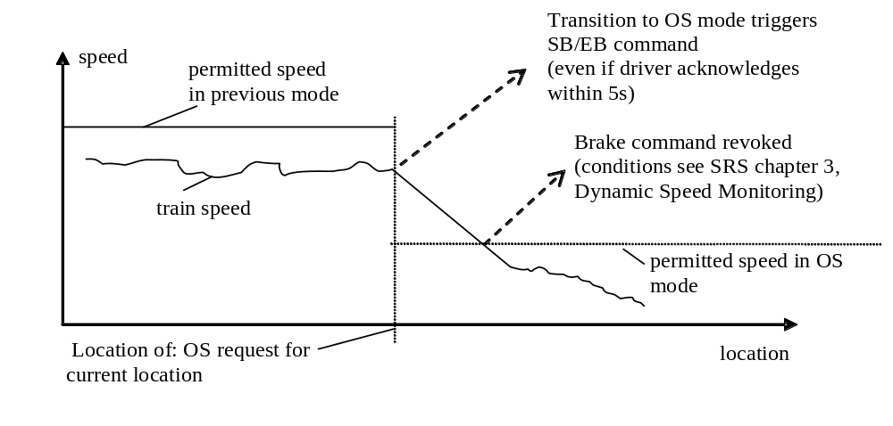
Figure 4: Train enters OS area with too high speed

Note: This sharp brake reaction can be avoided in Full Supervision or Limited Supervision mode by giving with the previous MA an EOA (or a LOA = OS mode speed limit) at the location of transition to On Sight mode. In Staff Responsible mode, lateral signals (if available) can also order the driver to decrease the train speed.

If the ERTMS/ETCS on-board equipment is already in OS mode when receiving the OS mode profile, no further acknowledgement shall be requested from the driver.

On Sight is requested for a further location

The beginning of the On Sight area can be a location that the train has not reached yet. This occurs when:
- In a level 1 area, a balise group gives a Mode Profile with an On Sight area that is located at a further location.
- In a level 2 or 3 area, the RBC gives a Mode Profile with an On Sight area that is located at a further location.

A request for acknowledgement shall be displayed to the driver when the following conditions are fulfilled:
- The distance between the estimated front end of the train and the beginning of On Sight area is shorter than a value, contained in the mode profile.
- The speed is lower than the On Sight mode speed limit (national value, or value given in the mode profile).
- The current mode is not On Sight

Note: The first 2 conditions define the “rectangle of acknowledgement”.

Once the acknowledgement request is displayed, it is not taken back if the train leaves the “rectangle of acknowledgement” (for example: because the train accelerates).

Until the ERTMS/ETCS on-board equipment has switched to OS mode, according to the mode profile, the beginning of the On Sight area shall be temporarily considered either as the EOA (keeping the SvL given by the MA) or as both the EOA and SvL (instead of the EOA and SvL given by the MA), with no Release Speed.

When the driver acknowledges the On Sight mode, the ERTMS/ETCS on-board equipment shall immediately switch to the On Sight mode.
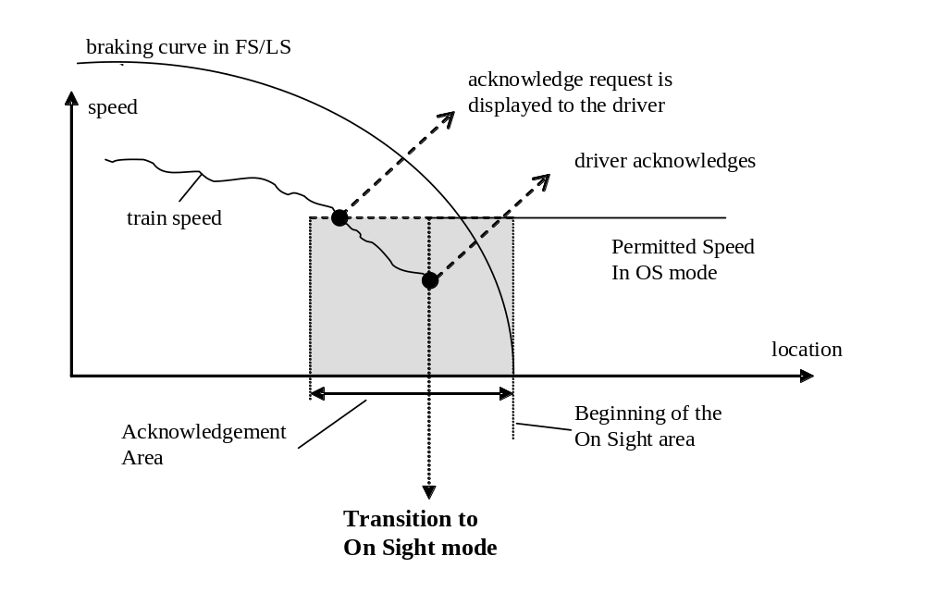
Figure 5: Transition from FS/LS to OS mode after driver acknowledgement

If the max safe front end of the train reaches the beginning of the On Sight area according to the mode profile and the driver has not yet acknowledged, the ERTMS/ETCS on-board equipment shall switch immediately to OS mode and a request for acknowledgement shall be displayed to the driver (refer to SRS chapter 4, transitions between modes).

If, in this case, the driver does not acknowledge within the driver acknowledgement time (refer to Appendix A3.1) after the change to OS mode, the service brake command shall be triggered. The command shall be released as soon as the driver acknowledges (unless the command was triggered also for other reasons).

On Sight from Unfitted or SN mode

The mode profile with regards to an OS area is only evaluated in levels 1,2,3, although the mode profile may have been received in level 0 (Unfitted mode) or NTC (SN mode). A transition to On Sight mode can therefore earliest occur at a transition of level: from level 0 or NTC to level 1 or 2 or 3.

Specifications of chapters 5.9.2 and 5.9.3 about the acknowledgement shall apply here.

On Sight from Stand By or Post Trip mode

When performing a SoM or a Train Trip procedure and when the current level is 2 or 3, the ERTMS/ETCS on-board equipment can receive a mode profile giving an On Sight area which the train has already entered with its max safe front end. In this case, the ERTMS/ETCS on-board equipment shall first require an acknowledgement from the driver.

When the driver acknowledges, the ERTMS/ETCS on-board equipment shall perform the transition to On Sight mode.”

Exit of On Sight mode

General rule

The ERTMS/ETCS on-board equipment exits the On Sight mode when the min safe front end of the train passes the end of the On Sight area.

First case: The On Sight area ends at the EOA of the current MA

This occurs when the end of the On Sight area that is given by the Mode Profile has the same location as the EOA of the related MA.

In this case, the train must receive a new Movement Authority to be able to exit the On Sight area.

Note: In an On Sight area there is no guarantee for the RBC that the track in front of the supervised train is free. Therefore, if the next block section is free, the RBC has nevertheless to ensure that there is no train/vehicle between the train and the end of the On Sight area. This information
- can be given to the RBC by the signalman or any other trackside means (outside scope of ERTMS/ETCS), or
- can be inquired by the RBC by means of the following mechanism: the RBC sends a “track ahead free” request which the ERTMS/ ETCS on-board equipment displays to the driver. If the driver confirms that the track is free up to the end of the current section, the ERTMS/ ETCS on-board equipment will transmit this information to the RBC.

Note: Receiving the “track ahead free” information, the RBC may be able to transmit an MA from the current position of the train, e.g., for Full Supervision (refer to SRS chapter 4, transitions between modes).

Second case: The On Sight area ends before the EOA of the current MA

In this case, the current Movement Authority already allows the train to exit the On Sight area.

When exiting the On Sight area, the ERTMS/ETCS on-board equipment switches either to Full Supervision, to Limited Supervision or to Shunting mode (refer to SRS chapter 4, transitions between modes).

Flowchart
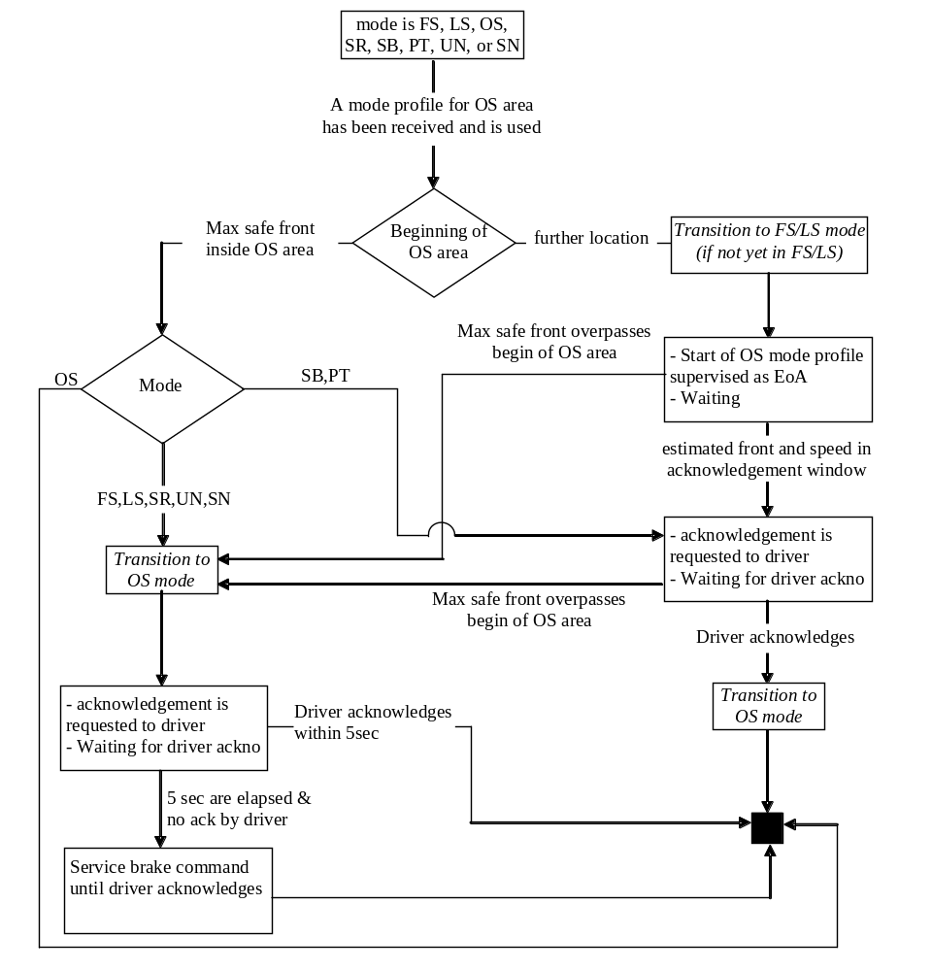
Figure 6: Flowchart for “On-Sight”

Level Transitions

General requirements

Every level transition border to levels 2, 3, or NTC shall be announced to the ERTMS/ETCS on-board equipment via balise group or via the RBC.

A level transition announcement to the ERTMS/ETCS on-board equipment shall consist of an order to execute the level transition at a further location corresponding to the border.

When the ERTMS/ETCS on-board equipment receives a level transition announcement, and if this announcement will result in a change of the on-board level, it shall immediately inform the driver about the announced level transition.

Note: In a mixed level area the actual level of the on-board equipment may remain unchanged even though a level transition boundary is passed.

At the level transition border a balise group shall be placed with an immediate level transition order or a conditional level transition order.

Note: Balise groups are read in all levels and level transition orders and conditional level transition orders from balises are accepted independent of the level of operation. Also sleeping units read balise groups.
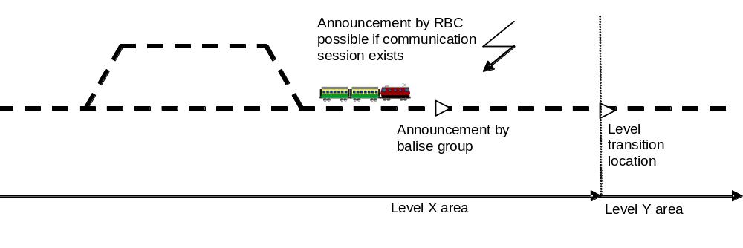
Figure 7: Transition from level X area to level Y area

If the message from the border balise group is not received, the level transition shall still be executed when the estimated front end passes the location given in the announcement.

The on-board equipment shall manage only one level transition order at a time. Therefore a new level transition order shall replace a previously received order, i.e. if a new order to switch to a different level or to the same level but at a different location is received, before the action from the first order has been performed, only the last order shall be executed.

In Shunting and Passive Shunting modes only one set of Level Transition Information shall be stored at a time. Therefore a set of Level Transition Information received shall replace any Level Transition Information already stored on-board.

As soon as the announcement of the level transition has been received, some data (mainly movement authority and track description data) from the transmission media of the new level shall be accepted, but shall not be used until the level transition is effective.

Note: for the exhaustive list of accepted/rejected information, please refer to SRS chapter 4.8.

Note: if only track description has been received from the new media without any movement authority, this track description still replaces the one previously received from the current media when the transition is performed.

When the onboard has performed the level transition, further data (mainly movement authority and track description data) received from the transmission media of the level being left shall be rejected.

Note: for the exhaustive list of accepted/rejected information, please refer to SRS chapter 4.8.

Intentionally deleted.

Table of priority of trackside supported levels

Any combination of ERTMS/ETCS levels 0, NTC, 1, 2, and 3 on a given area shall be possible.

The level transition announcement and the immediate or conditional level transition order at the border shall contain all the supported ERTMS/ETCS levels with a table of priority. Even if only one level is permitted this is considered as a table of priority.

Note: Level 0 is considered in the same way as the other levels. This means that, for example, when an area permits ERTMS/ETCS level 0, and is fitted with ERTMS/ETCS level 1 and 2, the track-side includes levels 0, 1 and 2 in a table of priority of supported levels in all level transition orders and conditional level transition orders applying to that area.

The table of priority shall list all the supported levels from the highest priority level to the lowest one.

Intentionally deleted.

When receiving the information about all ERTMS/ETCS levels that are supported by trackside, the ERTMS/ETCS on-board equipment shall select from the table the level with the highest priority, which is available for use by the onboard equipment.

The on-board equipment shall consider an ERTMS/ETCS level as “Available for use” as follows:
- Level 2 or 3: the level is configured on-board and at least one Mobile Terminal is available on-board, i.e. the ETCS onboard has detected at least one Mobile Terminal in working condition, independently whether it is registered to a network or not.
- Level NTC: the concerned National System is available on-board (if an STM is used, refer to SUBSET-035 for further details).
- Level 0 or 1: always.

Note regarding a) and b): how the ERTMS/ETCS on-board equipment checks the availability of the Mobile Terminals or of the National System (in case no STM is used) is an implementation issue.

Examples: The table of trackside supported levels gives 2, NTC X, 1, NTC Y. If level 1, 0 and NTC X are “Available for use”, the ERTMS/ETCS on-board will select NTC X level. If level 1, 0 and NTC Y are “Available for use”, it will select level 1. If level 2, 1 and 0 are “Available for use”, it will select level 2.

When the onboard has selected the level it will switch to, it shall carry out the level transition as if it has received a level transition order to this level only i.e. it shall ignore the requirements related to transitions to the other levels.

The ERTMS/ETCS on-board equipment shall inform the driver about the selected level transition only.

If none of the ordered level(s) is available for use by the ERTMS/ETCS on-board equipment, it shall nevertheless make the transition, to the ordered level with the lowest priority.

Justification: The On-board equipment will then indicate the trackside level to the driver to allow him to select the correct procedures for degraded situations.

The ERTMS/ETCS on-board equipment shall store the table of priority of trackside supported ERTMS/ETCS levels.

Intentionally deleted.

Intentionally deleted.

Intentionally deleted.

Specific Additional Requirements

Transition from Level 1 to Level 2/3 area

An order to connect to the RBC with a given id and telephone number shall be given via balise group in rear of the border location.

For the train to be able to enter the new area, the old area must possess information about at least the first section of the new area. The information may be transmitted to the train either:
- as an MA and track description information into the new area, or
- as a target speed at the border location i.e. as an LOA.

When the ERTMS/ETCS communication session is open, Train Data shall be sent to the RBC (which acknowledges the data) unless the onboard equipment is in SL or NL mode.

If no Level 2/3 MA and track description has been received when entering the new area, the train shall still be supervised according to the level 1 MA previously received.

When the ERTMS/ETCS on-board equipment has switched to the new level, it shall report the new on-board level, including a position report.

If an order to connect to an RBC has been received and the train will not enter the announced RBC area, an order to terminate the session shall be sent either from balises or from the RBC for any route not leading to the RBC area. This is the case both if the train turns back and if the train continues in the same direction, but on another route.

Transition from Level 0 (Unfitted) to Level 2/3 area

An order to connect to the RBC with a given id and telephone number shall be given via balise group in rear of the border location.

When the ERTMS/ETCS communication session is open, Train Data shall be sent to the RBC (which acknowledges the data) unless the onboard equipment is in SL or NL mode.

A level 2/3 MA and track description information shall be received from the RBC before the level transition border. If not, the train shall be tripped at passage of the border, i.e. after switching to level 2 or 3, movement is not allowed without a movement authority (refer to SRS chapter 4, transitions between modes).

The driver is responsible for entering the level 2/3 area at a speed not exceeding the speed limits of the unequipped line.

When the ERTMS/ETCS on-board equipment has switched to the new level, it shall report the new on-board level, including a position report.

If an order to connect to an RBC has been received and the train will not enter the announced RBC area, an order to terminate the session shall be sent either from balises or from the RBC for any route not leading to the RBC area. This is the case both if the train turns back and if the train continues in the same direction, but on another route.

Transition from Level 2/3 to Level 1 area

For the train to be able to enter the new area, the old area must possess information about at least the first section of the new area. The information may be transmitted to the train either
- as an MA and track description information into the new area, or
- as a target speed at the border location i.e. as an LOA.

If no Level 1 MA and track description has been received when entering the new area, the train shall still be supervised according to the level 2/3 MA previously received from the RBC.

When the train has passed the level transition border with its min safe rear end, i.e. when the whole train has left the level 2/3 area, the onboard equipment of the leading engine shall send a position report to the RBC.

After receiving this exit position report, the RBC can order the train to terminate the session (leading and non-leading engines).

Transition from Level 0 (Unfitted) to Level 1 area

A level 1 MA and track description information shall be received before or at the level transition border. If not, when the level transition is performed, the train shall be tripped, i.e. after switching to level 1, movement is not allowed without a movement authority (refer to SRS chapter 4, transitions between modes).

The driver is responsible for entering the level 1 area at a speed not exceeding the speed limits of the unequipped line.

Transition from Level 1 to Level 0 (Unfitted) area

For the train to be able to enter the new area, the old area must possess information about at least the first section of the new area. The information may be transmitted to the train either
- as an MA and track description information into the new area, or
- as a target speed at the border location i.e. as an LOA.

Note: When entering UN mode, all MA and track description data is deleted (refer to SRS Chapter 4, What happens to stored data when entering a mode)

Transition from Level 2/3 to Level 0 (Unfitted) area

For the train to be able to enter the new area, the old area must possess information about at least the first section of the new area. The information may be transmitted to the train either
- as an MA and track description information into the new area, or
- as a target speed at the border location i.e. as an LOA.

When the train has passed the level transition border with its min safe rear end, i.e. when the whole train has left the level 2/3 area, the onboard equipment of the leading engine shall send a position report to the RBC.

After receiving this exit position report, the RBC can order the train to terminate the session (leading and non-leading engines).

Note: When entering UN mode, all MA and track description data is deleted (refer to SRS Chapter 4, What happens to stored data when entering a mode)

Transition from Level NTC to Level 2/3 area

An order to connect to the RBC with a given id and telephone number shall be given via balise group in rear of the border location.

When the ERTMS/ETCS communication session is open, Train Data shall be sent to the RBC (which acknowledges the data) unless the onboard equipment is in SL or NL mode.

A level 2/3 MA and track description information shall be received from the RBC before the level transition border. If not, the train shall be tripped at passage of the border, i.e. after switching to level 2 or 3, movement is not allowed without a movement authority (refer to SRS chapter 4, transitions between modes).

The driver is responsible for entering the level 2/3 area at a speed not exceeding the speed limits of the level NTC line.

When the level transition location is passed with the estimated front end a position report shall be sent to the RBC. In case the ERTMS/ETCS on-board equipment is interfaced to the National System through an STM, please refer to SUBSET-035 for the STM state transition order.

If an order to connect to an RBC has been received and the train will not enter the announced RBC area, an order to disconnect shall be sent either from balises or from the RBC for any route not leading to the RBC area. This is the case both if the train turns back and if the train continues in the same direction, but on another route.

Transition from Level NTC to Level 1 area

A level 1 MA and track description information shall be received before or at the level transition border. If not, when the level transition is performed, the train shall be tripped, i.e. after switching to level 1, movement is not allowed without a movement authority (refer to SRS chapter 4, transitions between modes).

The driver is responsible for entering the level 1 area at a speed not exceeding the speed limits of the Level NTC line.

In case the ERTMS/ETCS on-board equipment is interfaced to the National System through an STM, please refer to SUBSET-035 for the STM state transition orders in relation to the level transition announcement and border.

Transition from Level 1 to Level NTC area

For the train to be able to enter the new area, the old area must possess information about at least the first section of the new area. The information may be transmitted to the train either
- as an MA and track description information into the new area, or
- as a target speed at the border location i.e. as an LOA.

Intentionally deleted.

In case the ERTMS/ETCS on-board equipment is interfaced to the National System through an STM, please refer to SUBSET-035 for the STM state transition orders in relation to the level transition announcement and border.

Transition from Level 2/3 to Level NTC area

For the train to be able to enter the new area, the old area must possess information about at least the first section of the new area. The information may be transmitted to the train either
- as an MA and track description information into the new area, or
- as a target speed at the border location i.e. as an LOA.

Intentionally deleted.

When the train has passed the level transition border with its min safe rear end, i.e. when the whole train has left the level 2/3 area, the onboard equipment of the leading engine shall send a position report to the RBC.

After receiving this exit position report, the RBC can order the train to terminate the session (leading and non-leading engines).

In case the ERTMS/ETCS on-board equipment is interfaced to the National System through an STM, please refer to SUBSET-035 for the STM state transition orders in relation to the level transition announcement and border..

Transition from Level NTC (National System X) to Level NTC (National System Y)

Intentionally deleted.

In case the ERTMS/ETCS on-board equipment is interfaced to the National System through an STM, please refer to SUBSET-035 for the STM state transition orders in relation to the level transition announcement and border.

Intentionally deleted.

Transition from Level NTC to Level 0

In case the ERTMS/ETCS on-board equipment is interfaced to the National System through an STM, please refer to SUBSET-035 for the STM state transition orders in relation to the level transition announcement and border.

The driver is responsible for entering the level 0 area at a speed not exceeding the maximum speed of the Level NTC line.

Intentionally deleted.

Transition from Level 0 to Level NTC

Intentionally deleted.

In case the ERTMS/ETCS on-board equipment is interfaced to the National System through an STM, please refer to SUBSET-035 for the STM state transition orders in relation to the level transition announcement and border.

The driver is responsible for entering the level NTC area at a speed not exceeding the speed limits of the unequipped line.

Conditional level transition order

When the ERTMS/ETCS on-board equipment accepts a conditional level transition order the onboard shall check whether the current level is contained in the priority list of the conditional level transition order.

If the current level is contained in the priority list of the conditional level transition order, the onboard shall not change the level.

If the current level is not contained in the priority list of the conditional level transition order, the onboard shall evaluate the conditional level transition order in the same way as an immediate level transition order (see section 5.10.2).

In the same way as for a level transition order, the ERTMS/ETCS on-board equipment shall store the table of ERTMS/ETCS levels supported by trackside.

Note: The conditional level transition order allows to check, whether a train operates in a permitted level e.g. following a start of mission after a cold movement. The level of a train driving in a permitted level will not be changed, regardless of the priority of the current level operated by the train.

Transition initiated by driver

In addition to the level transitions ordered by trackside, it is also possible, at standstill, for the driver to change the ERTMS/ETCS level (refer to section 3.18.4.2).

If the driver changes the level to 2 or 3, the ERTMS/ETCS on-board equipment shall establish a communication session with the RBC:
- immediately if at least one Mobile Terminal is registered to a Radio Network and a valid RBC ID/ phone number is available, OR
- once the driver has selected the RBC contact information (by the same means as for Start of Mission), if either no Mobile Terminal is registered to a Radio Network or no valid RBC ID/phone number is available.

Note regarding b): If the level transition leads to TR mode, the request for RBC contact information is only displayed once the ERTMS/ETCS on-board equipment is in PT mode.

If the driver changes the level from 2 or 3 to any other, the ERTMS/ETCS on-board equipment shall report the new level to the RBC if a communication session is established. When receiving the level change report, the RBC shall order the communication session to be terminated.

Acknowledgement of the level transition

If defined so for the level transition (see table below), the driver shall be requested to acknowledge the transition
- when the max safe front end of the train has passed a trackside defined location in rear of the level transition border
- upon receipt of the order to switch to the new level immediately

Exception: An ERTMS/ETCS on-board equipment in NL mode shall not require an acknowledgement from the driver.

If the driver has not yet acknowledged within the driver acknowledgement time (refer to Appendix A3.1) after the level transition, a service brake command shall be initiated.

The driver shall then acknowledge the level transition in order to release the service brake command.

For the following transitions marked as “YES”, the level transition announcement shall define the location from where an acknowledgement is required:
 |  | Acknowledgement when entering
 |  | L 0 | L 1 | L 2 | L 3 | L NTC
Coming from ... | L 0 | - | No | No | No | Yes
Coming from ... | L 1 | Yes | - | No | No | Yes
Coming from ... | L 2 | Yes | No | - | No | Yes
Coming from ... | L 3 | Yes | No | No | - | Yes
Coming from ... | L NTC | Yes | Yes | Yes | Yes | Yes

Procedure Train Trip

Introduction

A train can be tripped for various reasons: refer to SRS chapter 4, mode transition table.

Table of requirements for “Train Trip” procedure

The ID numbers in the table are used for the representation of the procedure in form of a flowchart in section 5.11.3.

Procedure
ID # | Requirements | Level
S010 | The ERTMS/ETCS on-board equipment is in one of the following modes: FS, LS, OS, SR, SB, SH, SN or UN  When an event occurs, which leads to train trip reaction (E015 – refer to chapter 4, transitions between modes), the process shall go to A025. | 0,NTC, 1,2,3
A025 | The mode shall change to TR.  The process shall go to A030. | 1,2,3
D020 | If the level is 0/1/NTC, the process shall go to A035.  If the level is 2/3, the process shall go to A030.
A030 | The ERTMS/ETCS on-board equipment shall report the mode change to the RBC  The process shall go to A035. | 2, 3
A035 | All current MA and track description data, except track conditions, shall be deleted and new ones shall not be accepted  The process shall go to S050. | 1,2,3
S050 | The ERTMS/ETCS on-board equipment awaits standstill. While braking a border to a level 0 or NTC area may be passed.  When the train has come to standstill (E055), the process shall go to S060. | 0,1,2,3,NTC
S060 | The ERTMS/ETCS on-board equipment shall display the "Request for driver acknowledgement to Train Trip" to the driver.  When the driver acknowledges the Train Trip (E065), the process shall go to D080. | 0,1,2,3, NTC
D80 | If the level is 1, 2 or 3 the process shall go to A105.  If the level is 0 or NTC, the process shall go to D085 | 0,1,2,3,NTC
A105 | The mode shall change to PT and the ERTMS/ETCS on-board equipment revokes the emergency brake command.  For the supervision provided by the PT mode refer to SRS chapter 4.  The process shall go to D110. | 1,2,3
D085 | If no valid Train Data is stored on-board, the process shall go to A140  If valid Train Data is stored on-board, the process shall go to D090
A140 | The mode shall change to SH and the process shall END.
D090 | If the level is 0, the process shall go to A145.  If the level is NTC, the process shall go to A150.
A145 | The mode shall change to UN and the process shall END.
A150 | The mode shall change to SN and the process shall END. | 0,NTC
D110 | If the level is 1, the process shall go to S140.  If the level is 2 or 3, the process shall go to A115. | 1,2,3
A115 | The mode change to PT shall be reported to the RBC which shall acknowledge the mode report (Recognition of exit from TR).  The process shall go to S120. | 2, 3
S120 | The ERTMS/ETCS on-board equipment waits for the RBC to acknowledge the transition to PT.  When the acknowledgement is received from the RBC (E125), the process shall go to D130.  Note: See 5.11.4 for degraded situation (no response received).
D130 | If there is at least one pending emergency stop, the process shall go to S130.  If there are no pending emergency stops the process shall go to S140.
S130 | The ERTMS/ETCS on-board equipment waits for the RBC to revoke ALL pending emergency stops.  When all emergency stops are revoked (E135) the process shall go to S140. | 2,3
S140 | The ERTMS/ETCS on-board equipment shall offer the possibility to the driver to select "start" (only if train data has been previously entered), or to select SH  - if the driver selects "start" and the level is 1 (E150), the process shall go to S160  - and the driver selects "start" and the level is 2 or 3 (E155), the process shall go to S150  - If the driver selects SH (E145), the process shall continue in the same ways as the procedure “Shunting initiated by the driver”. If the SH request is refused by the RBC (E165) the process shall return to S140. | 1,2,3
S150 | The ERTMS/ETCS on-board equipment shall send an MA request to the RBC and wait.  - If an SR authorisation is received from RBC (E26), the process shall go to S160  - If an MA allowing OS/LS/SH is received from RBC (E175), the process shall go to S170  - If an MA allowing FS is received from RBC (E170), the mode shall change to FS (refer to SRS chapter 4, transitions between modes: transition from PT to FS) and the process shall END. | 2,3
S160 | The ERTMS/ETCS on-board equipment shall request an acknowledgement from the driver for running in SR mode. When the driver acknowledges (E180), the mode shall change to SR (refer to SRS chapter 4, transitions between modes: transition from PT to SR) and the process shall END. | 1,2,3
S170 | The ERTMS/ETCS on-board equipment shall request an acknowledgement from the driver for running in OS/LS/SH mode. When the driver acknowledges (E185), the mode shall change to OS/LS/SH (refer to SRS chapter 4, transitions between modes: transition from PT to OS/LS/SH) and the process shall END. | 2,3

Flowchart

The ID numbers in the flowchart refer to the ID numbers of the table in section 5.11.2.
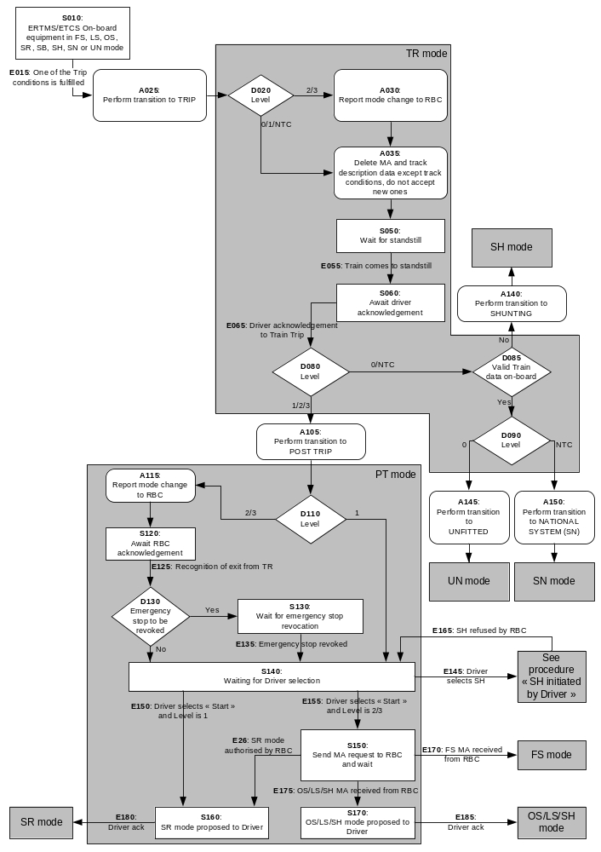
Figure 8: Flowchart for “Train Trip”

Degraded Situations

ERTMS/ETCS level 2 or 3: no acknowledge for PT mode is received from the RBC

In case a communication session is established and no reply is received from the RBC within a fixed waiting time (see appendix to chapter 3, List of Fixed Value Data) after reporting the mode change, the report shall be repeated with the fixed waiting time after each repetition.

After a defined number of repetitions(see appendix to chapter 3, List of Fixed Value Data) and if no reply is received within the fixed waiting time from the last sending of the mode change report, the ERTMS/ETCS onboard equipment shall terminate the communication session.

Nominally, accidental loss of an already open session (that can occur at any step) has not been taken into account for the design of the flowchart. However, should such a fault occur in any step while ERTMS/ETCS on-board equipment is in level 2/3 and in PT mode, the driver shall have the possibility to select "Override" and the process shall go to the procedure "Override "

Change of Train Orientation

Introduction

The scope of this procedure is the supervision of a train where the driver controls the train from the cab in the front of the train with the direction controller in FORWARD position.

This implies that when the driver has to change the orientation of the train, he has to change the driving cab.

The scope of this procedure is NOT shunting movements, during which the driver changes the running direction of the train without leaving the cab, by changing the position of the direction controller from FORWARD to REVERSE.

The scope of this procedure is NOT the backwards movement that is allowed in Post Trip or in Reversing mode.

The driver uses the same engine (a mission is on-going)

The situation is the following: The driver closes the desk A and leaves the cab A of the leading engine of the train, to go to cab B and open desk B of this same engine.

Desk A and desk B are connected to the same ERTMS/ETCS on-board equipment.

When the driver closes the desk A, the ERTMS/ETCS on-board equipment shall immediately go to Stand-By mode, which is considered as an end of mission (see “End of Mission” procedure)

When the driver opens the desk B, the “Start of Mission” procedure is triggered.

When the driver closes a desk and opens the other one of the same engine, the ERTMS/ETCS on-board equipment shall be able to calculate the new train position data (train front position, train orientation), by use of the previous data.

The driver leaves the engine to go to another one

The described situation is the following: The train has two engines (engine A and engine B). The engine A is the leading engine. The engine B is a slave engine. Each engine has its own ERTMS/ETCS on-board equipment.
- If engine B is remote controlled, its ETCS on-board equipment is in Sleeping mode.
Note: The mode is entered when on-board equipment detects the presence of the "remote control" signal.
- If the slave engine is not remote controlled (Tandem operation) by the leading engine but there is a driver who controls the engine, then the on-board equipment is in Non leading mode.
- If the engine B is not remote controlled (Tandem Shunting operation) by the leading engine and there is no driver who controls the engine, then the on-board equipment is in Passive Shunting mode.

Assumption: The train configuration does not change.
- When changing the train orientation, the leading engine A will become the slave engine, and the slave engine B will become the leading engine.
- If before the change of train orientation engine B was in SL, afterwards engine A will be in SL mode; If before the change of train orientation engine B was in NL, afterwards engine A will be in NL mode; If before the change of train orientation engine B was in PS, afterwards engine A will be in PS mode.

Case "Engine B was in SL mode"

The driver of engine A closes the desk, then the ERTMS/ETCS on-board equipment of engine A switches to Stand-By mode. If the train has a mission, this is a end of mission (see “End of Mission” procedure)

As soon as the remote control signal disappears, the ERTMS/ETCS on-board equipment of engine B switches to Stand-By mode.

Level 2,3: The ERTMS/ETCS on-board equipment of engine B shall open a communication session (if possible) and report the mode change to the RBC.

When the driver opens a desk of engine B he triggers the "Start of Mission" procedure.

Case "Engine B was in NL mode"

The driver of engine A selects "Non Leading". The ERTMS/ETCS equipment switches to Non Leading mode.

Once the non leading input signal is not received any more, the ERTMS/ETCS on-board equipment of engine B will switch to Stand-By mode (refer to SRS chapter 4, transitions between modes and chapter 5, “End of Mission” procedure).

Because the desk is open, when the ERTMS/ETCS on-board equipment enters Stand-By mode, the “Start of Mission” procedure is triggered.

Case "Engine B was in PS mode"

The driver of engine A selects "Continue Shunting on desk closure". The ERTMS/ETCS equipment switches to Passive Shunting mode once the driver closes the desk of engine A.

The driver opens a desk in engine B, and ERTMS/ETCS equipment switches to Shunting mode.

The driver uses the same engine (a Shunting movement is on-going)

The situation is the following: while the ERTMS/ETCS on-board equipment is in Shunting mode, the driver closes the desk A and leaves the cab A of the Shunting engine, to go to cab B and open desk B of this same engine.

Desk A and desk B are connected to the same ERTMS/ETCS on-board equipment.

Before closing the desk A, the driver enables the function “Continue Shunting on desk closure”. When the driver closes the desk A, the ERTMS/ETCS on-board equipment shall immediately go to Passive Shunting mode.

When the driver opens the desk B, the ERTMS/ETCS on-board equipment shall immediately switch back to Shunting mode.

When the driver closes a desk and opens the other one of the same engine, the ERTMS/ETCS on-board equipment shall be able to calculate the new train position data (train front position, train orientation), by use of the previous data.

Train Reversing

This procedure is intended to allow the fast reversal of movement of a train, to run away from a danger up to a “safe” location.

The area where initiation of reversing will be possible is announced to the ERTMS/ETCS on-board equipment by trackside (refer to 3.15.4.2 for details).

While the train is at standstill inside the reversing permitted area, the driver shall be informed that reversing is possible

If the ERTMS/ETCS onboard detects the driver’s intention to reverse (e.g. from a direction controller in reverse position), the ERTMS/ETCS on-board equipment shall ask the driver to acknowledge transition to RV mode.

If the driver acknowledges, the on-board equipment shall switch to RV mode

Once in RV mode, it shall be possible for the trackside to send a new permitted distance to run and a new maximum speed.

Once in RV mode, it shall also be possible for the trackside to send, together with the new permitted distance to run and the maximum speed, a new reference location for the new permitted distance to run.

Note: this new reference location is the end of a new reversing area given by trackside that the onboard will use only for the purpose of distance referencing.

Joining / Splitting

Definitions

Definition for splitting: The “train to be split” is the train at standstill, waiting for being split. The “front train after splitting” refers to the front part of the train before splitting, the “new train after splitting”, refers to the other part.

Definitions for joining: The “train to be joined” is the train at standstill, waiting for being joined. The “joining train” is the train performing the joining operation.

Procedure “Splitting”

Step 1 - The electrical and mechanical links between the two trains must be removed (this is a national operational procedure, out of the scope of the SRS).

Note: If splitting requires moving the two train parts apart from each other for a small distance, this can be done even in SB mode

Step 2a - If the ERTMS/ETCS onboard equipment which was supervising the train before splitting has not performed an end of mission for splitting, the driver must modify the Train Data such that it fits with the new train composition after splitting.
For level 2 or 3, the new train data is sent to the RBC (see SRS chapter 3 – Data Entry / Modification Process)

Step 2b - If an ERTMS/ETCS on-board equipment of the "new train after splitting" was in SL mode before, it will switch to SB mode once the remote control signal is not received any more (refer to SRS chapter 4, transitions between modes).
For Level 2 or 3: The ERTMS/ETCS on-board equipment shall open a communication session (if possible) and report the mode change to the RBC.

Step - 2c If an ERTMS/ETCS on-board equipment of the "new train after splitting" was in NL mode before, it will switch to SB mode once the non leading input signal is not received any more (refer to SRS chapter 4, transitions between modes and chapter 5, “end of mission” procedure).

The driver can then start a new mission with this “new train after splitting” (refer to the “Start of Mission” procedure). In all cases, to start a mission is not the only possibility. Shunting movements, or not moving the new train at all, are also possible.

Procedure “Joining”

Step 1 – The “joining train” must approach the “train to be joined”. This can be performed in SR, OS or SH mode (depending on the information available, and on the national procedure for joining).

Step 2 – The electrical and mechanical links between the two trains must be closed (vehicle dependent, outside the scope of the ETCS).

Step 3a – If a former leading ERTMS/ETCS on-board equipment remains leading and there was no end of mission, the driver must modify the Train Data such that it fits with the new train composition. For level 2 or 3, the new train data is sent to the RBC (see SRS chapter 3 – Data Entry / Modification Process)

Step 3b – If a former leading ERTMS/ETCS on-board equipment is to become slave equipment in SL mode, when closing the desk, the ERTMS/ETCS on-board equipment will switch to SB mode (see SRS chapter 4, transitions between modes) and the end of mission procedure is executed (see “End of Mission” procedure). Transition to SL mode is from SB mode.

Step 3c: If a former leading ERTMS/ETCS on-board equipment is to become slave equipment in NL mode, the driver selects NL mode (see SRS chapter 4, transitions between modes).

For further steps after joining refer to procedures “Start of Mission” and “Change of Train Orientation”.

RBC/RBC Handover

Principles

Every RBC/RBC handover shall be announced to the ERTMS/ETCS on-board equipment via a balise group or via the RBC.

The handover announcement (i.e. RBC transition order) to the ERTMS/ETCS on-board equipment shall consist of an order to contact the Accepting RBC (see 3.5.3.5.3) and to execute the handover at a further location corresponding to the border.

In case of RBC/RBC handover including Radio Network border crossing, ERTMS/ETCS trackside is responsible for the sequence of orders to register to the new Radio Network and to contact the "Accepting" RBC, according to the Radio Network’s configuration.

Note: In the following sections, "first" Mobile Terminal refers to the one used for communication session with “Handing Over” RBC and "second" Mobile Terminal to the one used for communication session with “Accepting” RBC.

Note: In the following sections, Radio Networks are supposed to be overlapped.

At the RBC/RBC border a balise group with an order to execute the handover immediately shall be placed.

Note: Balise groups are read in all levels and orders from balise groups are accepted independent of the level of operation. Also sleeping units read balise groups.

If the message from the border balise group is not (yet) received, the handover shall still be executed when the train with its max safe front end passes the border location according to the announcement information.

The on-board equipment shall manage only one RBC/RBC transition at a time, therefore a new transition order shall replace a previously received order.

Case 1: Two communication sessions can be handled simultaneously

Overview

In the normal operation, the main functional steps needed for running from one RBC area to another one are the following:
- Pre-announcement of the transition by the “Handing Over” RBC;
- Registration to the new Radio Network of second Mobile Terminal (optional) & Establishment of the radio communication session with the “Accepting” RBC;
- Generation of movement authorities including the border;
- Announcement of the RBC transition
- Transfer of train supervision to the “Accepting” RBC;
- Termination of the session with “Handing Over” RBC.
- Registration to the new Radio Network of first Mobile Terminal (optional)

Step by step description

Pre-announcement

When the “Handing Over” RBC generates a movement authority which reaches the border to another RBC area, it initiates the processes associated to the transition.

The “Handing Over” RBC informs the “Accepting” RBC about the RBC/RBC handover.

Registration to the new Radio Network of second Mobile Terminal (optional) & Establishment of the radio communication session with “Accepting” RBC

A radio communication session with the Accepting RBC is opened by the on-board equipment based on the RBC transition order received from the “Handing Over” RBC or from balise group (refer to chapter 3, section "management of radio communication").

In case of RBC/RBC handover including Radio Network border crossing, the registration to the new radio network of the second Mobile Terminal is completed before the RBC transition order is transmitted to the on-board equipment.

Generation of MAs including the border

The “Handing Over” RBC is responsible for establishing the movement authority based on:
- Information from the trackside equipment and interlocking of its own area (for the part of route related information up to the border),
- Information from the “Accepting RBC” for the part of route related information in advance of the border.
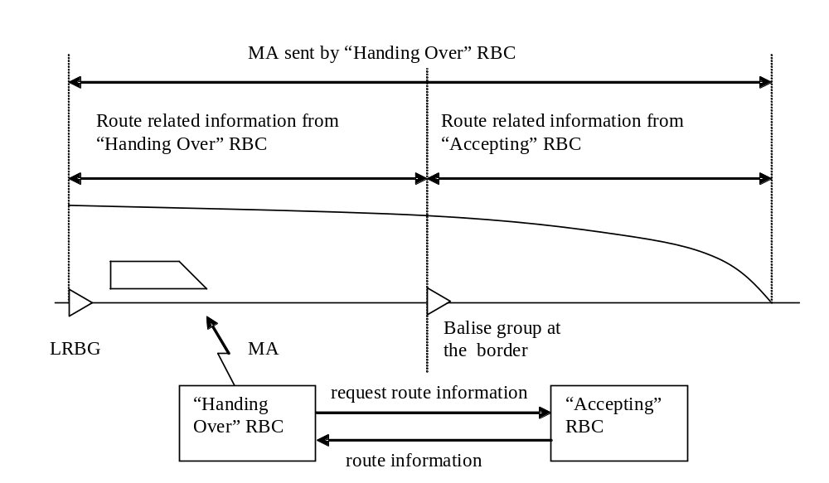
Figure 9: RBC to RBC transition: MA generation.

When it is required to send a movement authority to the train, the “Handing Over” RBC will request from the “Accepting” RBC information needed for extending the MA in advance of the border.

Announcement

When the train reaches the border with its max safe front end, the ERTMS/ETCS on-board equipment sends a position report both to the “Handing Over” RBC and to the “Accepting” RBC.

The “Handing Over” RBC forwards the announcement information to the “Accepting” RBC.

Note: Although not required for the case of two communication sessions, the forwarding of the announcement information is executed because the “Handing Over” RBC has no knowledge if the ERTMS/ETCS on-board equipment can handle one or two communication sessions.

Transfer of train supervision to “Accepting” RBC

As soon as the on-board has sent to the “Accepting” RBC the position report, it considers to be supervised by the “Accepting” RBC i.e. it uses information received from the “Accepting” RBC.

When the “Accepting” RBC receives a position report from the on-board and detects that the max safe front end has passed the border, it takes over the responsibility and informs the “Handing Over” RBC.

Termination of the session with “Handing Over” RBC

When the min safe rear end of the train passes the location of the border, the ERTMS/ETCS on-board equipment sends a position report to the “Handing Over” RBC.

When this position report is received by the ”Handing Over” RBC, it sends an order to terminate the session to the ERTMS/ETCS on-board equipment.

Registration to the new Radio Network of first Mobile Terminal (optional)

In case of RBC/RBC handover including Radio Network border crossing, the registration to the new Radio Network of the first Mobile Terminal is initiated by the ERTMS/ETCS on-board equipment as soon as the communication session with the "Handing Over" RBC has been terminated and the safe radio connection has been released.

Case 2: Only one communication session can be handled

Overview

In this case, the main functional steps needed for running from one RBC area to another one are the following:
- Pre-announcement of the transition by the “Handing Over” RBC;
- Generation of movement authorities including the border;
- Announcement of the RBC transition
- Termination of the session with “Handing Over” RBC;
- Registration to the new Radio Network of the Mobile Terminal (optional) & Establishment of the radio communication session with the “Accepting” RBC;
- Transfer of train supervision to the “Accepting” RBC.

Step by step description

Pre-announcement

When the “Handing over” RBC generates a movement authority which reaches the border to another RBC area, it initiates the processes associated to the transition.

The “Handing Over” RBC informs the “Accepting” RBC about the RBC/RBC transition.

Generation of MAs including the border

The “Handing Over” RBC is responsible for establishing the movement authority based on (see Figure 9)
- Information from the trackside equipment and interlocking of its own area (for the part of route related information up to the border),
- Information from the “Accepting RBC” for the part of route related information in advance of the border.

When it is required to send a movement authority to the train, the "Handing Over" RBC will request from the "Accepting RBC" information needed for extending the MA in advance of the border.

Announcement

When the train with its max safe front end reaches the border, the ERTMS/ETCS on-board equipment sends a position report to the “Handing Over” RBC.

The “Handing Over” RBC forwards the announcement information to the “Accepting” RBC.

Termination of the session with “Handing Over” RBC

As requested by the RBC transition order, when the min safe rear end of the train passes the location of the border, the on-board equipment sends a position report to the “Handing Over” RBC.

When this position report is received by the “Handing Over” RBC, it sends an order to terminate the session to the ERTMS/ETCS on-board equipment.

Registration to the new Radio Network of the Mobile Terminal (optional) & Establishment of the radio communication session with “Accepting” RBC

When the ERTMS/ETCS on-board equipment receives the session termination order from the “Handing Over” RBC, it terminates the session with the “Handing over” RBC and opens a session with the “Accepting” RBC (refer to chapter 3, management of radio communication).

In case of RBC/RBC handover including Radio Network border crossing: as soon as the session with the "Handing Over" RBC is terminated, the registration to the new Radio Network of the Mobile Terminal is enforced by the ERTMS/ETCS on-board equipment prior to the opening of a session with the “Accepting” RBC (refer to chapter 3, management of radio communication).

Transfer of train supervision to “Accepting” RBC

When the ERTMS/ETCS on-board equipment has established a communication session with the “Accepting” RBC and sent to the “Accepting” RBC a position report, it considers to be supervised by the “Accepting” RBC, i.e. it accepts only information received from the “Accepting” RBC.

When the “Accepting” RBC receives a position report from the on-board and detects that the max safe front end has passed the border, it takes over the responsibility and informs the “Handing Over” RBC.

Degraded Situations

Note: If the “Handing Over” RBC is not able to extend the MA into the area of the “Accepting RBC”, the driver may select "override", or manually change the level to move the train into the area of the “Accepting RBC”.

Note: If the ERTMS/ETCS on-board equipment cannot open a session with the “Accepting RBC”, the train is stopped at the latest when it has reached the EOA given by the “Handing Over” RBC. For passing the EOA the driver may select "override", or manually change the level.

If the ERTMS/ETCS on-board equipment is not able to terminate the session with the “Handing Over” RBC: In case a communication session is established and no request to terminate the session is received from the “Handing Over” RBC within a fixed waiting time (see appendix to chapter 3, List of Fixed Value Data) after sending the position report (see 5.15.2.2.6), the position report shall be repeated with the fixed waiting time after each repetition.

After a defined number of repetitions (see appendix to chapter 3, List of Fixed Value Data), and if no reply is received within the fixed waiting time from the last sending of the position report, the ERTMS/ETCS onboard equipment shall terminate the communication session.

Procedure passing a non protected Level Crossing

General Requirements

In case the LX is not protected, the ERTMS/ETCS on-board equipment (in FS, LS or OS mode) shall temporarily supervise the LX start location as both the EOA and SvL (instead of the EOA and SvL given by the MA), with no release speed.

The supervision of the LX start location as both the EOA and SvL shall be substituted by the inclusion of the LX speed restriction in the MRSP under conditions depending on whether stopping in rear of the LX start location is required or not. The conditions of this substitution are specified in 5.16.2 or 5.16.3.

The start location of the LX speed restriction depends on the substitution conditions, which are specified in 5.16.2 or 5.16.3. The end location of the LX speed restriction shall be the LX end location.

When approaching a non protected LX, the on-board equipment shall inform the driver about the status of the LX, as soon as:
- either the EOA or the SvL related to the LX start location becomes the Most Restrictive Displayed Target (see 3.13.10.4.2), or
- the ERTMS/ETCS on-board equipment substitutes the supervision of the LX start location as both the EOA and SvL by the inclusion of the LX speed restriction in the MRSP.

Indication given to the driver shall remain displayed until one of the following conditions is met:
- information “LX is protected” is received on-board;
- train has passed the LX end location with its min safe front end.

Stopping in rear of non protected LX is required

Once the train has stopped with its estimated front end inside the stopping area, given by trackside, the ERTMS/ETCS on-board equipment shall no longer supervise the LX start location as both the EOA and SvL (i.e. the ones given by the MA shall be again supervised) and shall immediately include the LX speed restriction in the MRSP, starting from the estimated train front end.
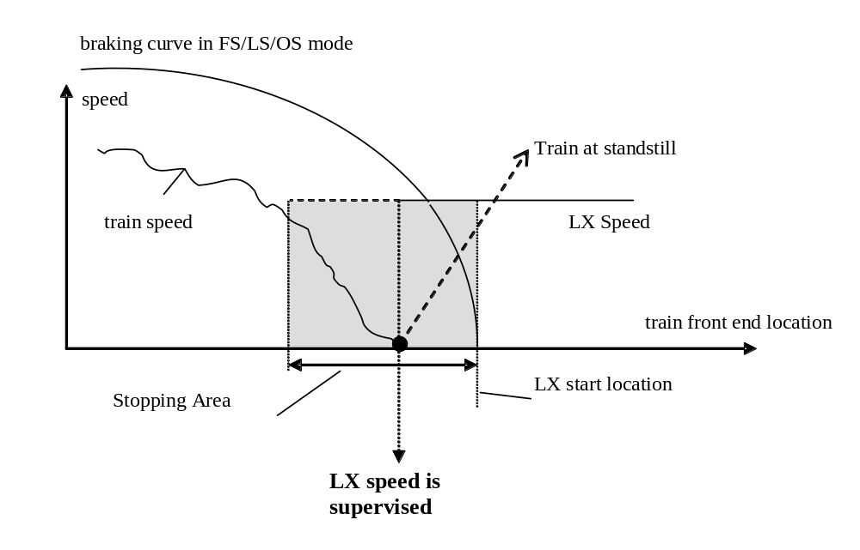
Figure 10: Approaching a non protected LX with stopping required

Stopping in rear of non protected LX is not required

In case stopping in rear of the non protected LX is not required, the LX start location shall be supervised as both the EOA and SvL until the train reaches the location of the braking to target Permitted speed supervision limit calculated for the LX speed (see 3.13.9.3.5.11&12 for the calculation of this location).

As soon as the estimated or the max safe front end (depending whether the FLOI at LX speed is the SBI1 or the SBI2) reaches the location of the Permitted speed supervision limit calculated for the LX speed, the ERTMS/ETCS on-board equipment shall no longer supervise the LX start location as both the EOA and SvL (i.e. the ones given by the MA shall be again supervised) and shall immediately include the LX speed restriction in the MRSP, starting from the train front end (estimated or max safe), which has reached the concerned Permitted speed supervision limit location.

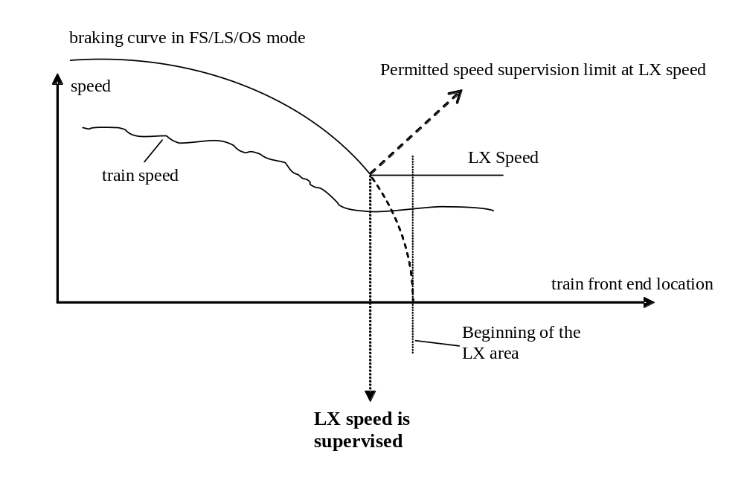
Figure 11: Approaching a non protected LX with stopping not required

Note: A braking curve to zero, instead of a braking curve to the LX speed at the LX start location, will ensure that the train is able to stop before the start location of the level crossing, in case this latter is not free for the train to pass. Close to the level crossing it is then the responsibility of the driver to proceed or not with LX speed as a maximum.

Changing Train Data from sources different from the driver

Introduction

When valid Train Data is stored on-board, input information acquired from ERTMS/ETCS external sources different from the driver may affect some of the Train Data, depending on the type of train (e.g. tilting input information from tilting external device may affect the train category and the loading gauge).

The procedure here below describes the necessary steps performed by the ERTMS/ETCS on-board equipment from the detection of an input information change on an external interface, to the effective encountering of the Train Data change by the ERTMS/ETCS on-board equipment.

This procedure is not applicable for trains running in RV mode: on leaving RV mode, the Train Data will always be invalidated or deleted.

Table of requirements for “Changing Train Data from sources different from the driver” procedure

The ID numbers in the table are used for the representation of the procedure in form of a flow chart in section 5.17.3.

Procedure
ID # | Requirements
S0 | The ERTMS/ETCS on-board equipment is in one of the following modes: FS, LS, OS, SR, SB, SN, UN, TR, PT and valid Train Data is stored on-board.  If a change of input information, which affects Train Data, is detected on an ERTMS/ETCS on-board external interface (E0), the process shall go to D0
D0 | According to the specific train implementation, Train Data which is/are affected by the change of input information from the ERTMS/ETCS on-board equipment external interface may require validation:  - If the affected data requires driver validation, the process shall go to D2  - If the affected data does not require driver validation, the process shall go to D1
D1 | Depending on the type of Train Data which is/are affected by the change of input information from the ERTMS/ETCS on-board external interface, the following shall apply:  - If the impacted Train Data regards either train category, or axle load category, or traction system(s) accepted by the engine, or loading gauge, the process shall go to D3  - If the impacted Train Data regards any other type of Train Data, the process shall go to A1
D3 | Depending on the mode of the ERTMS/ETCS on-board equipment, the following shall apply:  - If mode is FS, LS, or OS, the process shall go to D7  - If mode is SB or PT, the process shall go to A1  - If mode is UN, SN, SR, or TR the process shall go to D5
D5 | The ERTMS/ETCS on-board equipment shall check whether MA and track description, received from RBC, are stored on-board, in case a level 2/3 transition or a RBC transition for a further location has been ordered:  - If MA and track description are stored, the process shall go to D7  - If MA and track description are not both stored, the process shall go to A1
D7 | The ERTMS/ETCS on-board equipment shall check whether the train is at standstill:  - If at standstill, the process shall go to A1  - If not at standstill, the process shall go to S2
A1 | The ERTMS/ETCS on-board equipment shall inform the driver that Train Data has been changed and the process shall go to A7
S2 | The ERTMS/ETCS on-board equipment shall command the service brake, inform the driver about the reason of this brake command and waits for the train to be at standstill; when the ERTMS/ETCS on-board equipment detects that the train is at standstill (E2), the process shall go to S3
S3 | The ERTMS/ETCS on-board equipment shall request the driver to acknowledge the brake command; when the driver acknowledges (E3), the process shall go to A5
A5 | The ERTMS/ETCS on-board equipment shall release the brake command and the process shall go to A7
D2 | Depending on the mode of the ERTMS/ETCS on-board equipment, the following shall apply:  - If mode is FS, LS, OS, SR, SB, SN or UN the process shall go to D9  - If mode is TR or PT, the process shall go to S1
S1 | The ERTMS/ETCS on-board equipment shall wait for the end of the Train Trip procedure (see section 5.11). When the Train Trip procedure is exited (E1) (i.e. there is a mode transition to another mode than TR, PT), the process shall go to D4
D4 | Depending on the mode of the ERTMS/ETCS on-board equipment, the following shall apply:  - If mode is FS, LS, OS, SR, SN or UN the process shall go to S6  - If mode is SH, the Train Data are invalidated and the process shall END
D9 | The ERTMS/ETCS on-board equipment shall check whether the train is at standstill:  - If at standstill, the process shall go to S6  - If not at standstill, the process shall go to S4
S4 | The ERTMS/ETCS on-board equipment shall command the service brake, inform the driver about the reason of this brake command and wait for the train to be at standstill; when the ERTMS/ETCS on-board equipment detects that the train is at standstill (E4), the process shall go to S5
S5 | The ERTMS/ETCS on-board equipment shall request the driver to acknowledge the brake command; when the driver acknowledges (E5), the process shall go to A6
A6 | The ERTMS/ETCS on-board equipment shall release the brake command and the process shall go to S6
S6 | The ERTMS/ETCS on-board equipment shall request the driver to re-enter or re-validate the Train Data.  Once Train Data is validated (E6), the process shall go to A7
A7 | The ERTMS/ETCS on-board equipment shall consider the Train Data as being changed and shall apply, when relevant, the requirements regarding change of Train Data (refer to clauses 3.18.3.4, 3.18.3.7 and 3.18.3.8).  The process shall END.

Flowchart

The ID numbers in the flowchart refer to the ID numbers of the table in section 5.17.2.

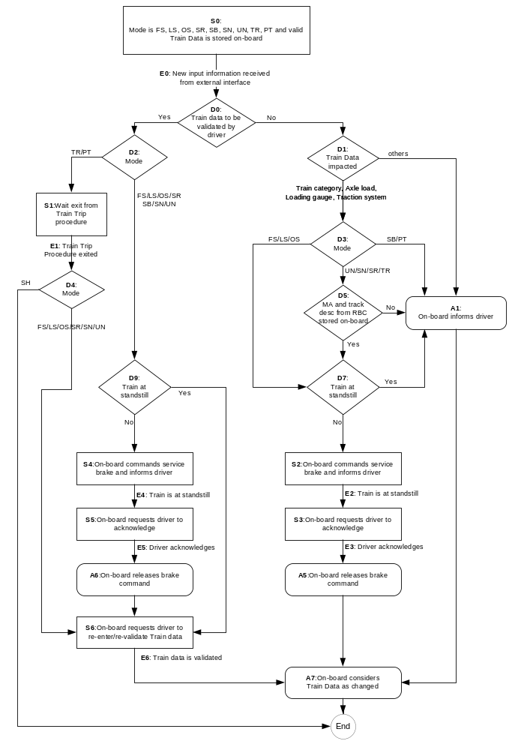
Figure 12: Flowchart for “Changing Train Data from sources different from the driver”

Indication of Track Conditions

Introduction

This set of procedures specifies the sequences of driver indications related to the following track-conditions:
- powerless section with pantograph to be lowered
- powerless section with main power switch to be switched off,
- non-stopping area,
- radio hole,
- air tightness area,
- Inhibition of a defined type of brake,
- tunnel stopping area,
- sound horn,
- change of traction system.

Note: For every procedure a figure supports the textual description. The textual description of the procedures contains reference to the figures (point B, point F,…).

Passing a powerless section with pantograph to be lowered

This procedure is dealing with the announcement and indication to the driver of a powerless section with the pantograph to be lowered.

Intentionally deleted.

“Lower pantograph announcement” shall be displayed to the driver when the max safe front end of the train reaches a location (point C) in rear of the beginning of the powerless section (point D).

This location (point C) shall be determined by the ERTMS/ETCS on-board equipment taking into account the time necessary for performing the required actions and the current train speed.

The displayed “Lower pantograph announcement” information shall also indicate if the related functionality is executed
- automatically, or
- if the driver is requested to act.

Note: Whether the operation is automatic or manual is application dependent.

When the max safe front end of the train reaches the start location (point D) of the powerless section:
- “Lower pantograph announcement” shall no longer be displayed to the driver,
- “Lowered Pantograph” information shall be displayed to the driver.

Intentionally deleted.

Intentionally deleted.

When the min safe front end of the train reaches the “Powerless section” end location point E):
- “Lowered Pantograph” information shall no longer be displayed to the driver
- “Raise pantograph” information shall be displayed to the driver.

The displayed “Raise pantograph” information shall also indicate if the related functionality is executed
- automatically, or
- if the driver is requested to act.

Note: Whether the operation is automatic or manual is application dependent.

The “Raise pantograph” information shall remain displayed for a fixed time (see Appendix A3.1) after the minimum safe rear end of the train has passed the end of the “Powerless section”.

Note: The train front end position when this information disappears is shown as point G in the Figure 13.

running direction
A
G
Display: «Raise pantograph»
Display: «Lowered Pantograph»

Distance to begin of powerless section
D
E
C
Display: «Lower pantograph announcement»
Powerless section length
Powerless section
LRBG
Figure 13: Passing a powerless section with pantograph to be lowered

Passing a powerless section with main power switch to be switched off

This procedure is dealing with the announcement and indication to the driver of a powerless section with main power switch to be switched off.

“Neutral section announcement” shall be displayed to the driver when the max safe front end of the train reaches a location (point C) in rear of the beginning of the powerless section.

This location (point C) shall be determined by the ERTMS/ETCS on-board equipment taking into account the time necessary for performing the required actions and the current train speed.

The displayed “Neutral section announcement” information shall also indicate if the related functionality is executed
- automatically, or
- if the driver is requested to act.

Note: Whether the operation is automatic or manual is application dependent.

When the max safe front end of the train reaches the starting location (point D) of the powerless section:
- “Neutral section announcement” shall no longer be displayed to the driver,
- “Neutral section” information shall be displayed to the driver.

When the min safe front end of the train reaches the “Powerless section” end location point E):
- “Neutral section” information shall no longer be displayed to the driver
- “End of Neutral section” information shall be displayed to the driver.

The displayed “End of Neutral section” information shall also indicate if the related functionality is executed
- Automatically, or
- if the driver is requested to act.

Note: Whether the operation is automatic or manual is application dependent.

The “End of Neutral section” information shall remain displayed for a fixed time (see Appendix A3.1) after the minimum safe rear end of the train has passed the end of the “Powerless section”.

Note: The train front end position, when this information disappears is shown as point G in the Figure 14.

running direction
Display: «Neutral section»
Distance to begin of powerless section
D
E
C
Display: «Neutral section announcement»
Powerless section length
LRBG
Display: «End of Neutral section»
G
A
Powerless section
Figure 14: Passing a powerless section with main power switch to be switched off

Passing a non stopping area

This procedure is dealing with the announcement and indication to the driver of an area where stopping is not permitted.

As long as there are non stopping areas stored on-board, the ERTMS/ETCS on-board equipment shall continuously check the current speed and position of the train whether a full service brake command would stop the train within the closest non stopping area. This shall be achieved taking into account two virtual SBI supervision limits (SBI_{D} and SBI_{G}), calculated at the estimated speed from two SBD curves of which the feet are the start location of the non stopping area (point D) and a location (point G) at train length distance in advance of the end location of the non stopping area:
- If the max safe front end is in rear of the first SBI supervision limit (SBI_{D}) no information related to this non stopping area shall be displayed
- If the max safe front end is in advance of first SBI supervision limit and the min safe front end in rear of the second SBI supervision limit, the non stopping area related information shall be displayed to the driver.
- If the min safe front end is in advance of the second SBI supervision limit (SBI_{G}), no information related to this non stopping area shall be displayed and the next non stopping area stored on-board, if any, shall be checked.

When the max safe front end reaches the first SBI supervision limit (point C), the “Non stopping area announcement” shall be displayed to the driver.

When the max safe front end reaches the start location (point D) of the non stopping area:
- “Non stopping area announcement” shall no longer be displayed
- “Non stopping area” information shall be displayed to the driver.

When the min safe front end reaches the second SBI supervision limit (point F), the non stopping area information shall no longer be displayed.

Note: the display of the “non stopping area” information will always end before the min safe rear end reaches the point E, because of the condition 5.18.4.2 c).
Non Stopping Area length
running direction
Distance to begin of Non Stopping Area
D
C
No display of Non Stopping Area information
LRBG
Display: «Non Stopping Area announcement»
G
Train length
F
No display of Non Stopping Area information
Non Stopping Area
E
speed
A
Display: «Non Stopping Area»
Train speed
SBI_{G}
SBI_{D}
Figure 15: Passing a non stopping area

Passing a radio hole

This procedure is dealing with the automatic deactivation of the safe radio connection supervision inside an announced radio hole area.

When the max safe front end of the train passes the start location (point D) of the radio hole area, the “radio hole” indication shall be displayed to the driver.

When the min safe rear end of the train passes the end location (point E) of the radio hole area, the “radio hole” indication to the driver shall be removed.

running direction
Radio hole length
Display: «radio hole»
Distance to begin of radio hole
A
D
E
LRBG
Radio hole area
Figure 16: Passing an announced radio hole

Passing an “air tightness” area

This procedure is dealing with the announcement and indication to the driver of an air tightness area.

“Close air conditioning intake announcement” information shall be displayed to the driver when the max safe front end of the train reaches a location (point C) in rear of the beginning of the “air tightness” area.

This location (point C) shall be determined by the ERTMS/ETCS on-board equipment taking into account the time necessary for performing the required actions and the current train speed.

The displayed “Close air conditioning intake announcement” information shall also indicate if the related functionality is executed
- automatically, or
- if the driver is requested to act.

Note: Whether the operation is automatic or manual is application dependent.

When the max safe front end of the train reaches the start location (point D) of the air tightness area:
- “Close air conditioning intake announcement” information shall no longer be displayed.
- “Air conditioning intake closed” information shall be displayed to the driver.

When the min safe rear end of the train reaches the end location (point E) of the air tightness area:
- “Air conditioning intake closed” information shall no longer be displayed;
- “Open air conditioning intake” information shall be displayed to the driver.

The displayed “Open air conditioning intake” information shall also indicate if the related functionality is executed
- automatically, or
- If the driver is requested to act.

Note: Whether the operation is automatic or manual is application dependent.

The “Open Air Conditioning intake” information shall remain displayed for a fixed time (see Appendix A3.1) after the minimum safe rear end of the train has passed the end of the “Air tightness area”.

Note: The train front end position, when this information disappears, is shown as point G in the Figure 17.
running direction
Air tightness length
Display « Air conditioning intake closed»
Distance to begin of air tightness area
A
D
E
C
Display: « Close air conditioning intake announcement »
LRBG
G
Display: «Open air conditioning intake»
Air tightness area
Figure 17: Passing an air tightness area

Inhibition of a defined type of brake

This procedure is dealing with the announcement and indication to the driver of the inhibition of defined types of brake systems.

The procedure shows the case of the regenerative brake. Regarding eddy current brake and magnetic shoe brake, the procedure is identical except that the displayed indications refer respectively eddy current brake or magnetic shoe brake.

“Inhibition of Regenerative Brake announcement” information shall be displayed to the driver when the max safe front end of the train reaches a location (Point C) in rear of the beginning of the regenerative brake inhibition area.

The displayed “Inhibition of Regenerative Brake announcement” information shall also indicate if the related functionality is executed
- automatically, or
- if the driver is requested to act.

Note: Whether the operation is automatic or manual is application dependent.

This location (point C) shall be determined by the On-Board equipment taking into account the time necessary for performing the required actions and the current train speed.

When the max safe front end of the train reaches the start location (point D) of the regenerative brake inhibition area:
- Indication “Inhibition of Regenerative Brake announcement” shall no longer be displayed,
- Indication “Inhibition of Regenerative Brake” shall be displayed to the driver.

When the min safe rear end of the train reaches the end location (point E) of the regenerative brake inhibition area the indication “Inhibition of Regenerative Brake” information shall no longer be displayed.
running direction
Brake inhibition length
Display: «Inhibition of Regenerative Brake»
Distance to begin of brake inhibition area
A
D
E
C
Display: «Inhibition of Regenerative Brake announcement»
LRBG
Brake inhibition area
Figure 18: Passing an area where Regenerative Brake shall be inhibited

Advising a tunnel stopping area

This procedure is dealing with the indication to the driver of an area under a tunnel where stopping is permitted, and suitable escaping paths are provided.

Note: the tunnel stopping areas are designed in such a way that the passengers can step out, use a walkway along the track and reach the safe area, taking into account the longest admissible train in the tunnel stopped with its front end within the tunnel stopping area.

On driver request, the ERTMS/ETCS on-board equipment shall enable/disable the display of the tunnel stopping area related information (initial state: disabled).

As long as the display of the tunnel stopping areas is enabled (point C) and there are tunnel stopping areas stored on-board, the ERTMS/ETCS on-board equipment shall continuously check the current speed and position of the train to determine whether the driver can stop the train with the full service brake before reaching the end of the closest tunnel stopping area. This shall be achieved taking into account a virtual Permitted supervision limit (with no contribution of the GUI curve, if any), calculated at the estimated speed from an SBD curve of which the foot is the end location of the tunnel stopping area:
- If the train front end is in rear of the Permitted supervision limit, the tunnel stopping area related information shall be displayed to the driver.
- If the train front end is in advance of the Permitted supervision limit, no information related to this tunnel stopping area shall be displayed and the next tunnel stopping area stored on-board, if any, shall be checked.

Before the train reaches the start location (point D) of the tunnel stopping area, the “tunnel stopping area announcement” shall be displayed to the driver. This shall include the indication of the remaining distance to the start location of the tunnel stopping area.

When the train front end reaches the start location (point D) of the tunnel stopping area:
- “Tunnel stopping area announcement” shall no longer be displayed
- “Tunnel stopping area” information shall be displayed to the driver.

Note: the display of the “tunnel stopping area” information will always end before the point E is reached, because of the condition 5.18.8.3 b).
Tunnel Stopping Area length
running direction
Display: «Tunnel Stopping Area»
Distance to begin of Tunnel Stopping Area
D
E
C
No display of Tunnel Stopping Area information
LRBG
Display: «Tunnel Stopping Area announcement»
?
Tunnel Stopping Area
display toggle on
Tunnel Stopping Area
running direction
speed
A
Figure 19: Advising a tunnel stopping area

Sounding the horn

This procedure is dealing with the indication to the driver of a request to sound the horn.

“Sound horn” shall be displayed to the driver when the estimated front end of the train reaches a location (point C) in rear of the beginning of the “sound horn” area (point D).

This location (point C) shall be determined by the ERTMS/ETCS on-board equipment taking into account the time necessary for the driver to perform the required action (see Appendix A3.1) and the current train speed.

When the estimated front end of the train reaches the end location (point E) of the “sound horn” area, the indication “Sound horn” information shall no longer be displayed.

Note: In order not to encourage the driver to stop sounding the horn too early, the track condition “sound horn” is defined as an area so that the display of the indication “Sound horn” continues during a certain distance sent by trackside (i.e. until point E), after the theoretical location of the board on the line (i.e. point D).
running direction
Sound Horn length
Distance to begin of Sound Horn area
A
D
E
LRBG
Display: «Sound Horn»
Sound Horn Area
C
Figure 20: Sounding the Horn

Changing the traction system

This procedure is dealing with the announcement and indication to the driver of a change of traction system.

“Change of traction system announcement” shall be displayed to the driver when the max safe front end of the train reaches a location (point C) in rear of the location of change of traction system (point F).

This location (point C) shall be determined by the ERTMS/ETCS on-board equipment taking into account the time necessary for performing the required actions and the current train speed.

The displayed “Change of traction system announcement” information shall also indicate if the related functionality is executed
- automatically, or
- if the driver is requested to act.

Note: Whether the operation is automatic or manual is application dependent.

When the max safe front end of the train reaches the “Change of traction system” location (point F):
- the “Change of traction system announcement” information shall no longer be displayed to the driver,
- the “New traction system” information shall be displayed to the driver.

The “New traction system” information shall remain displayed for a fixed time (see Appendix A3.1) after the minimum safe rear end of the train has passed the “Change of traction system” location (point F).

Note: The train front end position when this information disappears is shown as point G in the Figure 21.
running direction
A
G
C
Display: «Change of traction system announcement»
Distance to change of traction system
F
Display: «New traction system»
LRBG
Figure 21: Changing the traction system

Procedure Limited Supervision

General Requirements

The order to switch to Limited Supervision mode shall be given by means of a mode profile.

An acknowledgement for running in Limited Supervision mode shall be requested from the driver. The conditions of the acknowledgement are specified below.

Limited Supervision is requested for current location (from modes different from Stand By and Post Trip)

In a level 1 area, the beginning of the Limited Supervision area can be the balise (group) that gives the Mode Profile. When the train passes the balise group and receives this information, the ERTMS/ETCS on-board equipment shall immediately switch to Limited Supervision mode.

In a level 2 or 3 area, the ERTMS/ETCS on-board equipment can receive a mode profile giving a Limited Supervision area which the train has already entered with its max safe front end. In this case, the ERTMS/ETCS on-board equipment shall immediately switch to Limited Supervision mode.

The driver must acknowledge the Limited Supervision mode. A request of acknowledgement shall be displayed to the driver.

If the driver has not acknowledged after the driver acknowledgement time (refer to Appendix A3.1), the service brake command shall be triggered. The brake command is released when the driver acknowledges, except if brakes are also applied for another reason(s).

Note: Once in Limited Supervision mode, the speed supervision is such that the train speed cannot exceed the LS mode speed limit. If, when entering the Limited Supervision mode, the train speed was higher than the LS mode speed limit (because a higher speed was allowed in Full Supervision mode, On Sight mode or in Staff Responsible mode) then an emergency brake command could be immediately triggered, independently of the acknowledgement of the driver, but because of the LS supervision (see Figure 22).
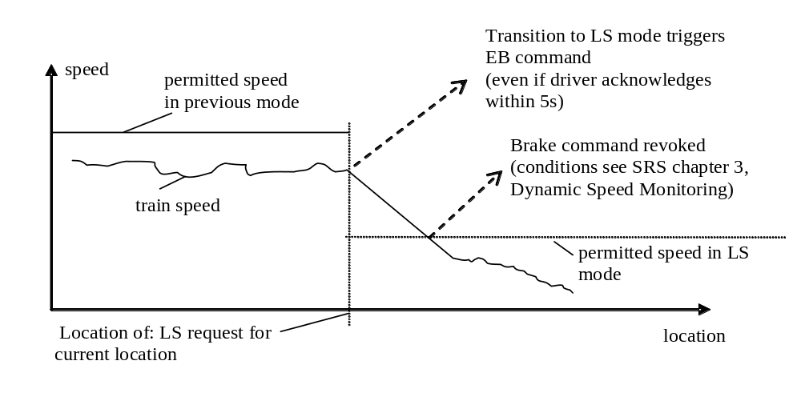
Figure 22: Train enters LS area with too high speed

Note: This sharp brake reaction can be avoided in Full Supervision or On Sight mode by giving with the previous MA an EOA (or a LOA = LS mode speed limit) at the location of transition to Limited Supervision mode.

If the ERTMS/ETCS on-board equipment is already in LS mode when receiving the LS mode profile, no further acknowledgement shall be requested from the driver.

Limited Supervision is requested for a further location

The beginning of the Limited Supervision area can be a location that the train has not reached yet. This occurs when:
- In a level 1 area, a balise group gives a Mode Profile with an Limited Supervision area that is located at a further location.
- In a level 2 or 3 area, the RBC gives a Mode Profile with an Limited Supervision area that is located at a further location.

A request for acknowledgement shall be displayed to the driver when the following conditions are fulfilled:
- The distance between the estimated front end of the train and the beginning of Limited Supervision area is shorter than a value, contained in the mode profile.
- The speed is lower than the Limited Supervision mode speed limit (national value, or value given in the mode profile).
- The current mode is not Limited Supervision

Note: The first 2 conditions define the “rectangle of acknowledgement”.

Once the acknowledgement request is displayed, it is not taken back if the train leaves the “rectangle of acknowledgement” (for example: because the train accelerates).

Until the ERTMS/ETCS on-board equipment has switched to LS mode, according to the mode profile, the beginning of the Limited Supervision area shall be temporarily considered either as the EOA (keeping the SvL given by the MA) or as both the EOA and SvL (instead of the EOA and SvL given by the MA), with no Release Speed.

When the driver acknowledges the Limited Supervision mode, the ERTMS/ETCS on-board equipment shall immediately switch to the Limited Supervision mode.
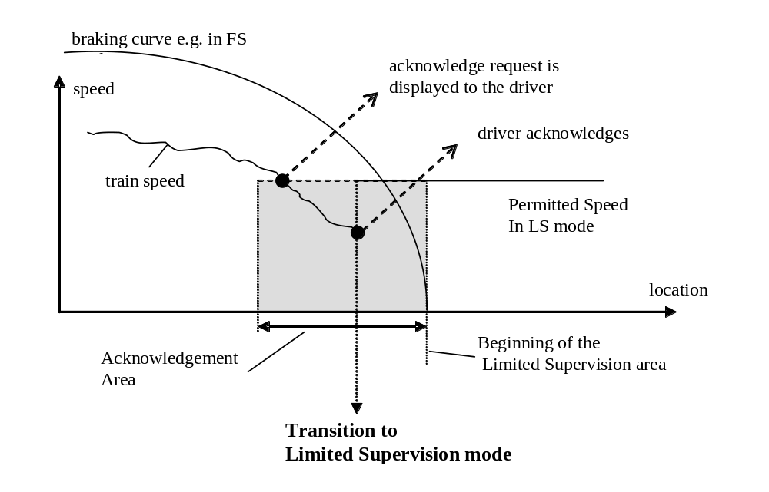
Figure 23: Transition to LS mode after driver acknowledgement

If the max safe front end of the train reaches the beginning of the Limited Supervision area according the mode profile and the driver has not yet acknowledged, the ERTMS/ETCS on-board equipment shall switch immediately to LS mode and a request for acknowledgement shall be displayed to the driver (refer to SRS chapter 4, transitions between modes).

If, in this case, the driver does not acknowledge within the driver acknowledgement time (refer to Appendix A3.1) after the change to LS mode, the service brake command shall be triggered. The command shall be released as soon as the driver acknowledges (unless the command was triggered also for other reasons).

Limited Supervision from Unfitted or SN mode

The mode profile with regards to an LS area is only evaluated in levels 1,2,3, although the mode profile may have been received in level 0 (Unfitted mode) or NTC (SN mode). A transition to Limited Supervision mode can therefore earliest occur at a transition of level: from level 0 or NTC to level 1 or 2 or 3.

Specifications of chapters 5.19.2 and 5.19.3 about the acknowledgement shall apply here.

Limited Supervision from Stand By or Post Trip mode

When performing a SoM or a Train Trip procedure and when the current level is 2 or 3, the ERTMS/ETCS on-board equipment can receive a mode profile giving an Limited Supervision area which the train has already entered with its max safe front end. In this case, the ERTMS/ETCS on-board equipment shall first require an acknowledgement from the driver.

When the driver acknowledges, the ERTMS/ETCS on-board equipment shall perform the transition to Limited Supervision mode.

Exit of Limited Supervision mode

General rule

The ERTMS/ETCS on-board equipment exits the Limited Supervision mode when the min safe front end of the train passes the end of the Limited supervision area.

First case: The Limited supervision area ends at the EOA of the current MA

This occurs when the end of the Limited Supervision area that is given by the Mode Profile has the same location as the EOA of the related MA.

In this case, the train must receive a new Movement Authority to be able to exit the Limited Supervision area.

Second case: The Limited Supervision area ends before the EOA of the current MA

In this case, the current Movement Authority already allows the train to exit the Limited Supervision area.

When exiting the Limited Supervision area, the ERTMS/ETCS on-board equipment switches either to Full Supervision, On Sight or to Shunting mode (refer to SRS chapter 4, transitions between modes).

Flowchart
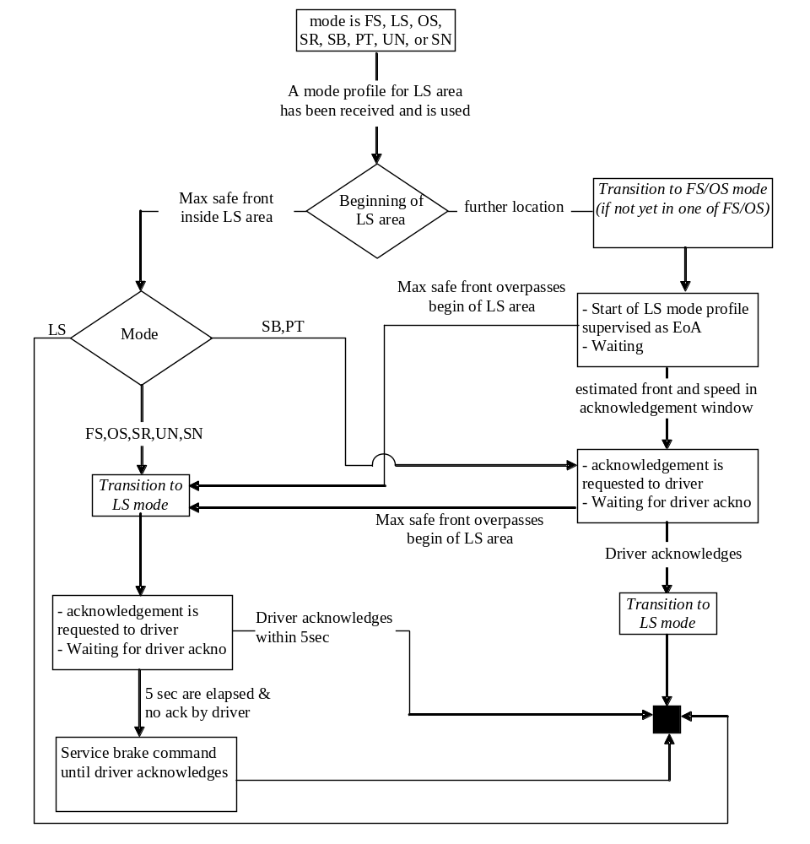
Figure 24: Flowchart for “Limited Supervision”

